 | vCenter Plug-in
 | User Guide
 | Issue | 05
 | Date | 2018-11-02


About This Document
Purpose
This document describes how to install and maintain the vCenter plug-in.
Intended Audience
This document is intended for:
- Technical support engineers
- System maintenance engineer
Symbol Conventions
The symbols that may be found in this document are defined as follows.
Symbol | Description
 | Indicates an imminently hazardous situation which, if not avoided, will result in death or serious injury.
 | Indicates a potentially hazardous situation which, if not avoided, could result in death or serious injury.
 | Indicates a potentially hazardous situation which, if not avoided, may result in minor or moderate injury.
Indicates a potentially hazardous situation which, if not avoided, could result in equipment damage, data loss, performance deterioration, or unanticipated results.
NOTICE is used to address practices not related to personal injury.
Calls attention to important information, best practices, and tips.
NOTE is used to address information not related to personal injury, equipment damage, and environment deterioration.

Change History
Changes between document issues are cumulative. The latest document issue contains all the changes made in earlier issues.
Issue 05 (2018-11-02)
Added 4 FAQs.
Issue 04 (2018-10-09)
Added 3.2.4.2 Upgrading the Firmware and Driver.
Issue 03 (2018-08-29)
Added 3.2.6 Receiving and Viewing Server Alarms.
Issue 02 (2018-06-29)
Added 3.2.5 Registering, Configuring, and Using Proactive HA.
Issue 01 (2017-09-29)
This issue is the first official release.
Contents
About This Document ii
1 Overview 1
2 Installing and Uninstalling the Huawei vCenter Plug-in 3
2.1 Installing the Huawei vCenter Plug-In 3
2.2 Uninstalling the Huawei vCenter Plug-in 8
3 Operation and Maintenance 15
3.1 Configuring eSight 15
3.1.1 Adding an eSight 15
3.1.2 Editing an eSight 18
3.1.3 Deleting eSight 20
3.2 Managing Servers 20
3.2.1 Viewing the Server List 20
3.2.2 Deploying an OS 22
3.2.2.1 Adding a Software Source 22
3.2.2.2 Creating an OS Template 26
3.2.2.3 Creating a Template Task 28
3.2.3 Managing Templates 30
3.2.3.1 Configuring Power Control 30
3.2.3.2 Configuring the BIOS 31
3.2.3.3 Configuring an HBA 39
3.2.3.4 Configuring RAID 41
3.2.3.5 Configuring a CNA 43
3.2.3.6 Configuring the iBMC 46
3.2.4 Upgrading the Firmware and Driver 49
3.2.4.1 Uploading an Upgrade Package 49
3.2.4.2 Upgrading the Firmware and Driver 51
3.2.5 Registering, Configuring, and Using Proactive HA 53
3.2.5.1 Registering the HA Provider 53
3.2.5.2 Configuring Proactive HA 55
3.2.5.3 Using Proactive HA 58
3.2.6 Receiving and Viewing Server Alarms 59
3.3 Viewing the Huawei vCenter Plug-in Version 62
4 FAQs 63
4.1 Connection Test Failed When Adding an eSight 63
4.2 Failed to Deploy an OS 65
4.3 Failed to Upload an Upgrade Package 69
4.4 How to Add a Server ESXi System to a vCenter Cluster 69

Overview
The Huawei vCenter plug-in is integrated in the vCenter software and used for Huawei server management. By adding eSight, you can deploy OSs, configure servers, upgrade, and monitor Huawei servers.
You can implement the following functions by using this plug-in:
- View server information and component information.
- Deploy server OSs in batches. For the supported OS types and versions, see Table 1-1.
- Configure CNAs, HBAs, BMCs, BIOSs, and RAIDs of servers.
- Upgrade server firmware and drivers.
- Provide Proactive HA Provider to implement isolation functions on abnormal servers.
Table 1-1 lists the servers supported by the Huawei vCenter plug-in.
                - Supported servers
Type | Server
Rack server | RH2288H V2
Rack server | RH1288 V3
Rack server | RH2288 V3
Rack server | RH2288H V3
Rack server | RH5885 V3
Rack server | RH8100 V3
Rack server | 1288H V5
Rack server | 2288H V5
Rack server | 2488 V5
Blade server | E9000
High-density server | XH321 V3
High-density server | XH620 V3
High-density server | XH622 V3
High-density server | XH628 V3

Installing and Uninstalling the Huawei vCenter Plug-in
2.1 Installing the Huawei vCenter Plug-In
2.2 Uninstalling the Huawei vCenter Plug-in

Installing the Huawei vCenter Plug-In
Prerequisites
- JRE 1.8.0 or later has been installed on the server.
- You have obtained the Huawei vCenter plug-in installation package Huawei vCenter Plugin X.X.zip and the deployment software package Huawei vCenter Plugin Upgrade X.X.zip. Here, X.X indicates the plug-in version number, for example, Huawei vCenter Plugin 1.0.zip.
- If the vCenter is installed on a Linux OS, you need to prepare a Windows-based PC for installing the plug-in.
Hardware Requirements
Recommended configurations:
- CPU: 8-core 2 GHz
- Memory capacity: 16 GB
- Hard disk: 500 GB
Procedure
            - Log in to the server as the administrator, and upload the Huawei vCenter plug-in installation package and deployment software package to the server.
            - Modify the Java environment variable.
Windows Server 2012 R2 is used as an example.
- In Control Panel, select Category from the View by drop-down list box.
- Choose System and Security > System > Advanced system settings.
The System Properties dialog box is displayed.
- On the Advanced tab page, click Environment Variables, as shown in Figure 1-1.
              - System Properties
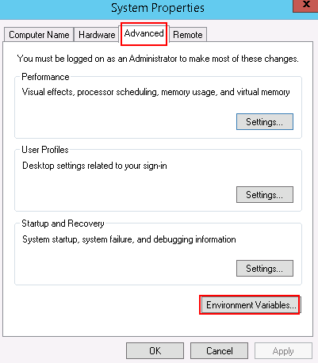

The Environment Variables dialog box is displayed.
- In the System Variables area, select the Path variable, and click Edit.
The Edit System Variable dialog box is displayed.
- Add a variable value, and click OK.
For example, add C:\Program Files\Java\jre1.8.0_121\bin to Variable value, as shown in Figure 1-2.
              - Edit System Variable
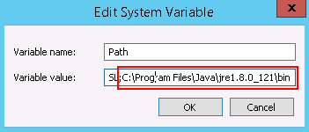

- Click OK.
- Click Apply, and click OK.
- Run CMD to open the CLI window, and run java -version to view the JRE version.
            - Decompress the deployment software package.
The Huawei vCenter plug-in installation package and the decompressed deployment software package (.jar file) must be stored in the same path.
            - Run CMD to open the CLI window, and run the following command to go to the path for storing the installation package and deployment software package:
cd path for saving the software package and deployment software package
            - Run the following command to start the deployment software package:


Keep the CLI window open when you install the Huawei vCenter plug-in. Otherwise, the installation page may fail to open.
java -jar Deployment software package name.jar
If information shown in Figure 1-1 is displayed, the deployment software is started.
              - Command output
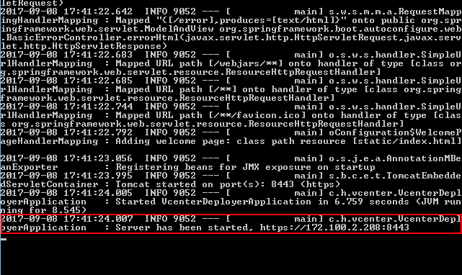

In the preceding command, 8443 is the default port number. To change the port number, run the following command:
java -jar Deployment software package name.jar --server.port=Customized port number
            - Open the browser on the local PC, enter https://vCenter IP address:8443 in the address box, and press Enter. The vCenter IP address can be obtained from the command output in Step 5.
The Huawei vCenter plugin update program page is displayed, as shown in, as shown in Figure 1-1.
              - Huawei vCenter plugin update program
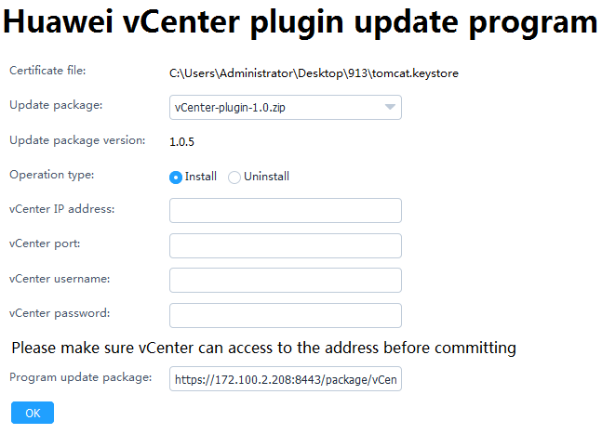

            - Set the following parameters, and click OK.
- Update package: Select the vCenter plug-in installation package.
- Operation type: Select Install.
- vCenter IP address: Enter the vCenter IP address where the plug-in is to be installed.
- vCenter port: Enter the vCenter port number. The default value is 443.
- vCenter username: Enter the vCenter administrator user name.
- vCenter password: Enter the vCenter administrator password.
            - In the CLI window, view the command output. If information shown in Figure 1-1 is displayed, the Huawei vCenter plug-in is successfully installed.
              - Command output
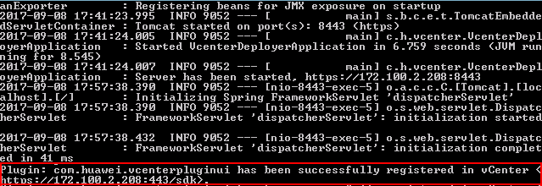

            - Open the browser on the local PC, enter https://vCenter IP address in the address box, and press Enter.
            - Select Flash to open the vCenter login page.
              - vCenter login
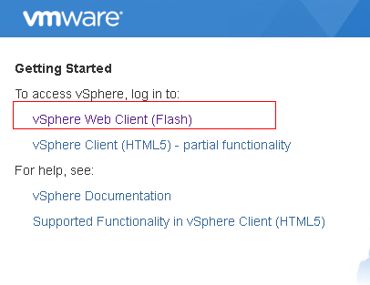

            - Enter the vCenter user name and password, and click Login.
The vCenter homepage is displayed.
If the icon in the red box shown in Figure 1-1 is displayed, the Huawei vCenter plug-in is successfully installed.
              - Homepage
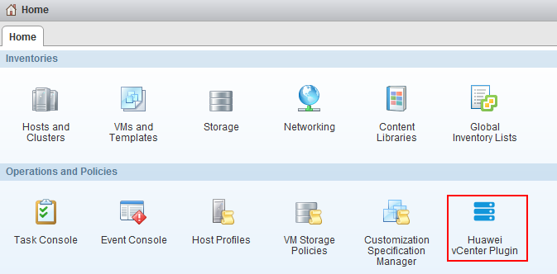

If you have logged in to vCenter, you need to log out and then log in again to view the Huawei vCenter plug-in icon.
----End

Uninstalling the Huawei vCenter Plug-in
Prerequisites
- JRE 1.8.0 or later has been installed on the server.
- You have obtained the Huawei deployment software package Huawei vCenter Plugin Upgrade X.X.zip, where X.X indicates the plug-in version.
- If the vCenter is installed on a Linux OS, you need to prepare a Windows-based PC for uninstalling the plug-in.
Procedure
            - Log in to the server as the administrator, and upload the deployment software package to the server.
            - Modify the Java environment variable.
Windows Server 2012 R2 is used as an example.
- In Control Panel, select Category from the View by drop-down list box.
- Choose System and Security > System > Advanced system settings.
The System Properties dialog box is displayed.
- On the Advanced tab page, click Environment Variables, as shown in Figure 1-1.
              - System Properties

The Environment Variables dialog box is displayed.
- In the System Variables area, select the Path variable, and click Edit.
The Edit System Variable dialog box is displayed.
- Add a variable value, and click OK.
For example, add C:\Program Files\Java\jre1.8.0_121\bin to Variable value, as shown in Figure 1-2.
              - Edit System Variable

- Click OK.
- Click Apply, and click OK.
- Run CMD to open the CLI window, and run java -version to view the JRE version.
            - Decompress the deployment software package.
            - Run CMD to open the CLI window, and run the following command to go to the path for storing the deployment software package:
cd Path for saving the deployment software package
            - Run the following command to start the deployment software package:

Keep the CLI window open when you uninstall the Huawei vCenter plug-in. Otherwise, the uninstall page may fail to open.
java -jar Deployment software package name.jar
If information shown in Figure 1-1 is displayed, the deployment software is started.
              - Command output

In the preceding command, 8443 is the default port number. To change the port number, run the following command:
java -jar Deployment software package name.jar --server.port=Customized port number
            - Open the browser on the local PC, enter https://vCenter IP address:8443 in the address box, and press Enter.
The Huawei vCenter plugin update program page is displayed, as shown in, as shown in Figure 1-1.
              - Huawei vCenter plugin update program
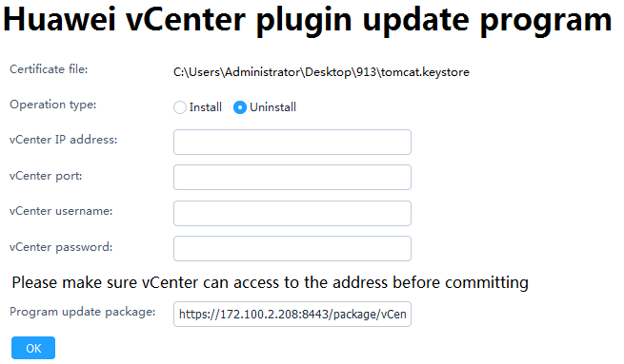

            - Set the following parameters, and click OK.
- Operation type: Select Uninstall.
- vCenter IP address: Enter the vCenter IP address where the plug-in is to be uninstalled.
- vCenter port: Enter the vCenter port number. The default value is 443.
- vCenter username: Enter the vCenter administrator user name.
- vCenter password: Enter the vCenter administrator password.
            - In the CLI window, view the command output. If information shown in Figure 1-1 is displayed, the Huawei vCenter plug-in is successfully uninstalled.
              - Command output
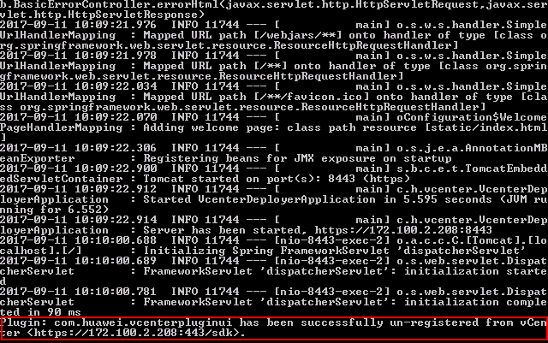

            - Open the browser on the local PC, enter https://vCenter IP address in the address box, and press Enter.
The vCenter login page is displayed.
            - Enter the vCenter user name and password, and click Login.
On the vCenter homepage, check whether the plug-in icon is deleted.
- If yes, no further action is required.
- If no, perform Step 11 to Step 12 to clear the browser cache and open the browser again.
            - Clear the browser cache.
Internet Explorer 11.0 is used as an example.
- Select Internet Options.
The Internet Options dialog box is displayed.
- Click Delete, as shown in Figure 1-1.
              - Internet Options
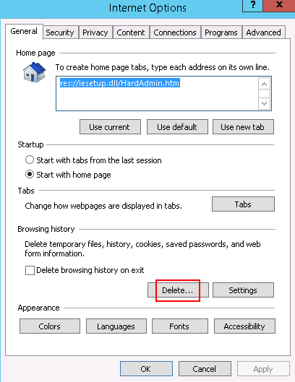

The Delete Browsing History dialog box is displayed.
- Select the information shown in Figure 1-2, and click Delete.
              - Delete Browsing History
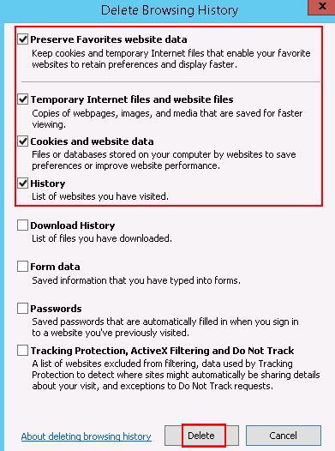

- Click Apply, and click OK.
            - Open the browser again, log in to vCenter, and check whether the plug-in icon is deleted.
- If yes, no further action is required.
- If no, contact Huawei technical support.
----End

Operation and Maintenance
3.1 Configuring eSight
3.2 Managing Servers
3.3 Viewing the Huawei vCenter Plug-in Version

Configuring eSight

Adding an eSight
            - Set a whitelist.
By default, a whitelist of eSight northbound ports is configured. To add an eSight properly, you must add the IP address of the server where vCenter is located to the whitelist of eSight northbound ports.
- Log in to the eSight WebUI.
- Choose System > Northbound Integration > Third-party System > Create.
The Third-party System page is displayed, as shown in Figure 1-1.
              - Third-party System
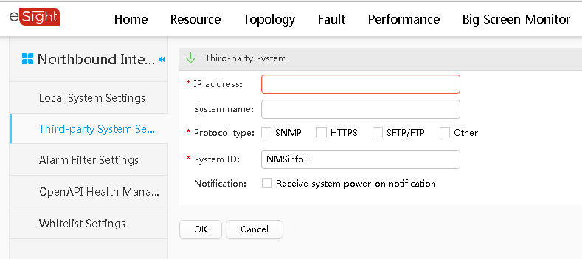

- Set the following parameters:
- IP address: IP address of the vCenter server
- Protocol type: HTTPS
- System ID: Retain the default value or enter a new value. The value can be an IP address or a string of 1 to 64 characters, including digits (0-9), lowercase letters (a-z), uppercase letters (A-Z), and special characters @_- (), .^$~`!.
- Click OK.
The IP address of the vCenter server is successfully added to the whitelist, as shown in Figure 1-2.
              - Whitelist configured successfully
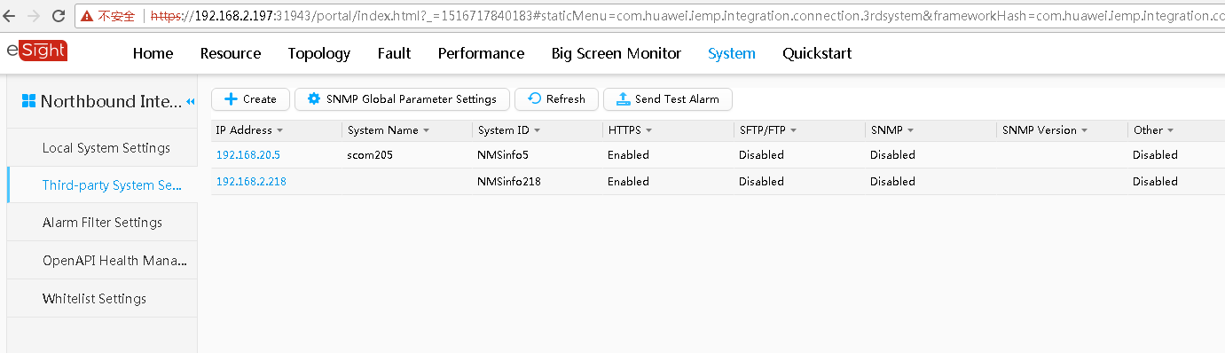

            - On the vCenter WebUI, choose Home > Operations and Policies > Huawei vCenter Plugin.
The Huawei vCenter Plugin page is displayed.
            - Select eSight Set.
The eSight Set page is displayed.
            - Click Add eSight.
The Add eSight dialog box is displayed.
            - Set the following parameters, and click Test, as shown in Figure 1-1.
              - Add eSight
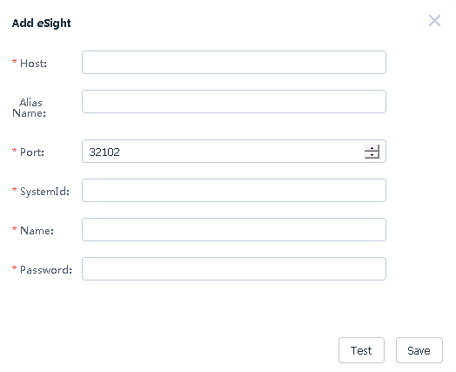

- Host: eSight IP address to be added
- Alias: name of the eSight to be added (Optional)
- Port: port number of the eSight to be added (default value: 32102)
- SystemId: same as the value of System ID in Step 1.3
- Name: User name of the eSight OpenAPI to be added (default value: openApiUser)
- Password: password of the eSight OpenAPI to be added (default value: Changeme_123) To change the password, follow the instructions in 4.1 Connection Test Failed When Adding an eSight.
If the connection is normal, a message indicating connection success is displayed. If the connection fails, a message indicating failed connection is displayed. For the failure cause, see 4.1 Connection Test Failed When Adding an eSight.
            - After the connection is set up, click Save to save the eSight configuration.
The Prompt dialog box is displayed.
            - Click OK.
The eSight is added.
On the eSight Setting page, view the added eSight, as shown in Figure 1-1.
              - eSight Setting
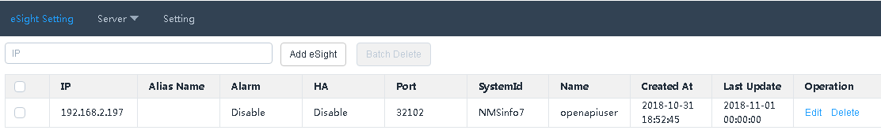

----End

Editing an eSight
            - On the vCenter WebUI, choose Home > Operations and Policies > Huawei vCenter Plugin.
The Huawei vCenter Plugin page is displayed.
            - Select eSight Set.
The eSight Set page is displayed.
            - In the row of the eSight to be edited, click Edit.
The Edit eSight dialog box is displayed.
            - Set the following parameters, as shown in Figure 1-1.
              - Edit eSight
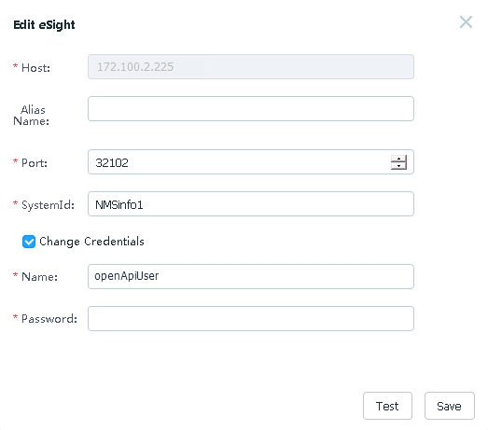

- Alias Name: name of the eSight
- Port: eSight port number
- SystemId: same as the value of System ID in Step 1.3
- Change Credentials: This parameter is deselected by default. You can select this parameter and change the eSight user name and password.
- Name: eSight user name
- Password: eSight password
After the eSight is connected, if the eSight port number, user name, or password is changed, you must synchronize the new port number, user name, or password to the Huawei vCenter plug-in; otherwise, server management of the Huawei vCenter plug-in will be affected.
            - Check whether Change Credentials is selected and the user name or password is changed.
- If yes, click Test. After the connection is set up, click Save to save the eSight configuration.
- If no, click Save to save the eSight configuration.
The Prompt dialog box is displayed.
            - Click OK.
The eSight editing is complete.
On the eSight Setting page, view the modified eSight, as shown in Figure 1-1.
              - eSight Setting

----End

Deleting eSight
            - On the vCenter WebUI, choose Home > Operations and Policies > Huawei vCenter Plugin.
The Huawei vCenter Plugin page is displayed.
            - Select eSight Set.
The eSight Set page is displayed.
            - In the row of the eSight to be deleted, click Delete, as shown in Figure 1-1.
              - Deleting eSight
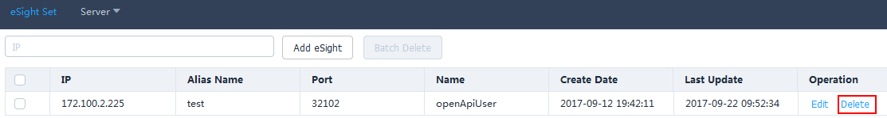

The Prompt dialog box is displayed.
To delete eSight systems in batches, select the eSight systems to be deleted, and click Batch Delete.
            - Click OK.
The eSight is deleted.
----End

Managing Servers

Viewing the Server List
            - On the vCenter WebUI, choose Home > Operations and Policies > Huawei vCenter Plugin.
The Huawei vCenter Plugin page is displayed.
            - Choose Server > Server List.
The server list page is displayed.
            - Select the eSight name and server type, and view the values of IP Address, Name, Status, and Model, as shown in Figure 1-1.
              - Server list
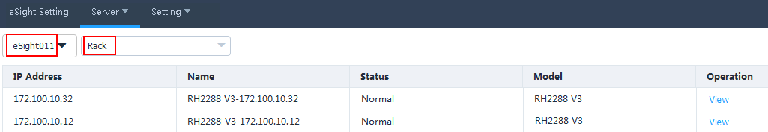

            - In the row of any server, click View.
View the basic information, online device status, and mainboard, CPU, memory, hard disk, PSU, fan, RAID, NIC, and PCIe information of the server, as shown in Figure 1-1.
              - Device status
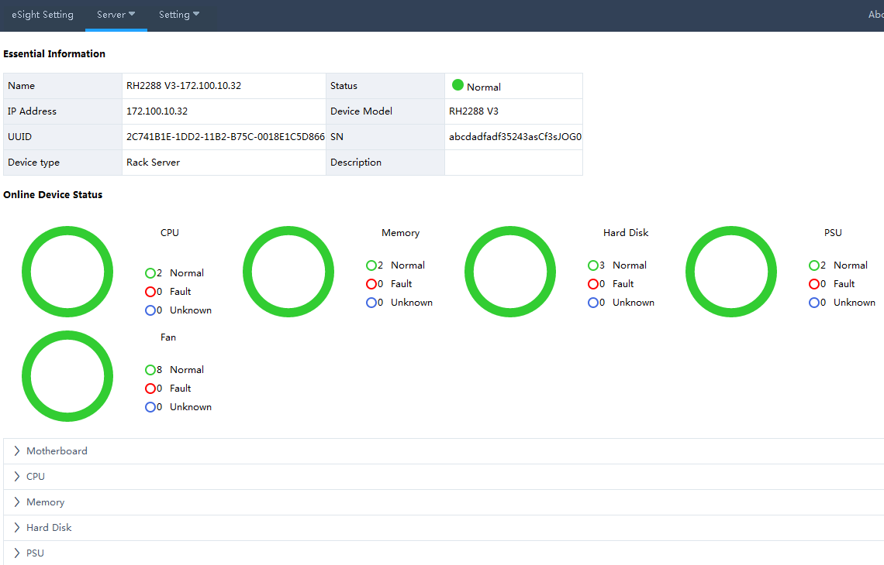

            - Click Back.
The Server List page is displayed.
----End

Deploying an OS

Adding a Software Source
Scenario
Adding a software source means adding an OS image file. When deploying an OS for a server, add an OS image file, an OS template, and then an OS deployment task.
Prerequisites
- The SFTP server for uploading the software source has been set up.
- The OS compatibility of the server has been confirmed using the Huawei Server Compatibility Checker, and Note1 is present in the Notes column. For details, see 4.2 Failed to Deploy an OS.
Procedure
            - Upload the OS image file to be added to the default directory on the SFTP server.
- The size of the OS image file must not exceed 5 GB.
- The capacity of the eSight installation disk must be greater than 40 GB.
            - On the vCenter WebUI, choose Home > Operations and Policies > Huawei vCenter Plugin.
The Huawei vCenter Plugin page is displayed.
            - Choose Server > Software Source Management.
The Software Source Management page is displayed.
            - Click Add.
The Add Software Source dialog box is displayed.
            - Set the following parameters, and click OK, as shown in Figure 1-1.
              - Add Software Source
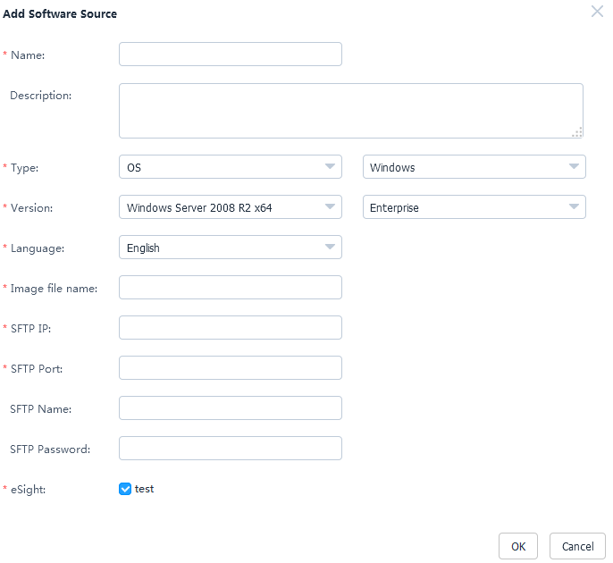

- Name: OS image file name
- Description: OS image file description (Optional)
- Type: OS type, which can be Windows, SUSE, Red Hat, CentOS, Ubuntu, or VMware ESXi
- Version: OS version. For details, see Table 1-1.
- Language: Select a language only when the OS type is Windows. Available options include Chinese and English.
- Image file name: name of image file on the SFTP server, for example, rhel-server-7.2-x86_64-dvd.iso
- SFTP IP: SFTP server IP address
- SFTP Port: SFTP server port number
- SFTP Name: SFTP server user name
- SFTP Password: SFTP server password
- eSight: name of the eSight for which you want to add an OS image file. You can select multiple eSight systems at the same time.
                - Supported software source versions
Software Source Type | Version
Windows | Windows Server 2008 R2 x64
Windows | Windows Server 2008 R2 SP1 x64
Windows | Windows Server 2012 x64
Windows | Windows Server 2012 x64
Windows | Windows Server 2012 x64
SUSE | SUSE Linux Enterprise 11 SP1 x64
SUSE | SUSE Linux Enterprise 11 SP2 x64
SUSE | SUSE Linux Enterprise 11 SP3 x64
SUSE | SUSE Linux Enterprise 11 SP4 x64
SUSE | SUSE Linux Enterprise 12 SP1 x64
SUSE | SUSE Linux Enterprise 12 SP2 x64
SUSE | SUSE Linux Enterprise 12 x64
Red Hat | Red Hat Linux Enterprise 6.1 x64
Red Hat | Red Hat Linux Enterprise 6.2 x64
Red Hat | Red Hat Linux Enterprise 6.3 x64
Red Hat | Red Hat Linux Enterprise 6.4 x64
Red Hat | Red Hat Linux Enterprise 6.5 x64
Red Hat | Red Hat Linux Enterprise 6.6 x64
Red Hat | Red Hat Linux Enterprise 6.7 x64
Red Hat | Red Hat Linux Enterprise 6.8 x64
Red Hat | Red Hat Linux Enterprise 6.9 x64
Red Hat | Red Hat Linux Enterprise 7.0 x64
Red Hat | Red Hat Linux Enterprise 7.1 x64
Red Hat | Red Hat Linux Enterprise 7.2 x64
Red Hat | Red Hat Linux Enterprise 7.3 x64
CentOS | CentOS Linux Enterprise 6.2 x64
CentOS | CentOS Linux Enterprise 6.3 x64
CentOS | CentOS Linux Enterprise 6.4 x64
CentOS | CentOS Linux Enterprise 6.5 x64
CentOS | CentOS Linux Enterprise 6.6 x64
CentOS | CentOS Linux Enterprise 6.7 x64
CentOS | CentOS Linux Enterprise 6.9 x64
CentOS | CentOS Linux Enterprise 7.0 x64
CentOS | CentOS Linux Enterprise 7.1 x64
CentOS | CentOS Linux Enterprise 7.2 x64
CentOS | CentOS Linux Enterprise 7.3 x64
Ubuntu | Ubuntu Linux Enterprise 14.04 x64
Ubuntu | Ubuntu Linux Enterprise 14.10 x64
Ubuntu | Ubuntu Linux Enterprise 16.04 x64
VMWare ESXi | VMWare ESXi 5.0 x64
VMWare ESXi | VMWare ESXi 5.1 x64
VMWare ESXi | VMWare ESXi 5.5 x64
VMWare ESXi | VMWare ESXi 6.0 x64
VMWare ESXi | VMWare ESXi 6.5 x64

The Prompt dialog box is displayed.
            - Click OK.
The software source is added.
On the Software Source Management page, view the added software sources, as shown in Figure 1-1.
              - Software Source Management
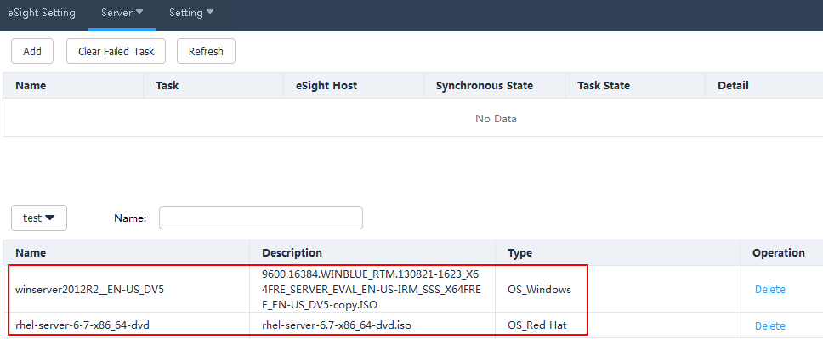

- Click Refresh to view the software source uploading progress.
- To delete a software source that fails to be uploaded, click Clear Failed Task. All software sources that fail to be uploaded will be deleted.
- To delete a software source that is successfully uploaded, click Delete in the row of the software source.
----End

Creating an OS Template
            - On the vCenter WebUI, choose Home > Operations and Policies > Huawei vCenter Plugin.
The Huawei vCenter Plugin page is displayed.
            - Choose Server > Template Management.
The Template Management page is displayed.
            - Click Create Template.
The Create Template page is displayed.
            - Set the following parameters, as shown in Figure 1-1.
              - Creating an OS template
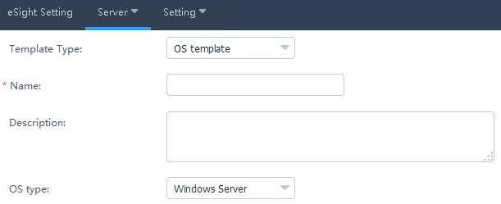

- Template Type: OS template
- Name: OS template name
- Description: OS template description (Optional)
- OS type: required OS type
            - In the OS Settings area, set the following parameters, as shown in Figure 1-1.
              - OS Settings
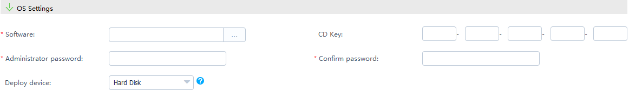

- Software: added software source
- CD Key: OS serial number. Set this parameter only when the OS type is Windows Server.
- Administrator password: OS administrator password
- Confirm Password: OS administrator password
- Deploy device: devices to be deployed
- If the OS type is VMware ESXi 5.0, the deployment device is Hard Disk.
- If the OS type is VMware ESXi 5.1/5.5/6.0, the deployment device is Hard Disk or USB device.
            - Set Partition Settings only when the OS type is Windows Server/SUSE Linux/Red Hat/CentOS, as shown in Figure 1-1.
              - Partition Settings
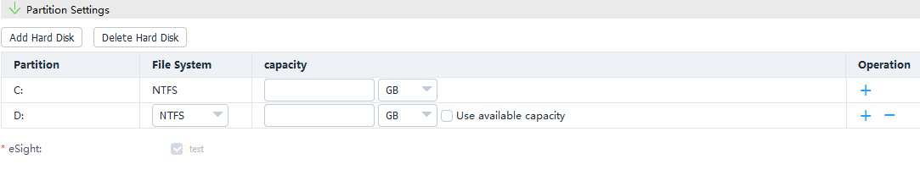

- Click Add Hard Disk.
- Set File System, enter the capacity of the new hard disk, and determine whether to use the remaining capacity based on the actual requirements.
- To add a partition for a hard disk, click .
- To delete a partition of a hard disk, click .
- To delete a hard disk, click Delete Hard Disk.
            - Click OK.
The Prompt dialog box is displayed.
            - Click OK.
The OS template is created.
On the Template Management page, view the created OS template, as shown in Figure 1-1.
              - Template Management
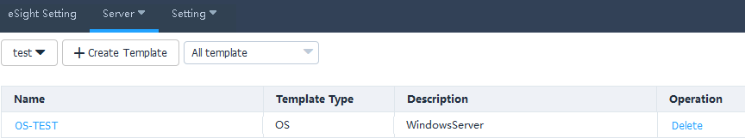

To delete a template, click Delete in the row of the template to be deleted.
----End

Creating a Template Task
Prerequisites
You have obtained the ServiceCD from the Software Download tab on the FusionServer Tools page at Huawei Enterprise support website, uploaded the decompressed package to eSight installation directory\AppBase\var\iemp\data\ftp, and changed the name of the ServiceCD file to FusionServer Tools-ServiceCD2.0-V110.iso.
The ServiceCD version is V137.
Procedure
            - On the vCenter WebUI, choose Home > Operations and Policies > Huawei vCenter Plugin.
The Huawei vCenter Plugin page is displayed.
            - Choose Server > Task Management.
The Task Management page is displayed.
            - Click Create Task.
The page for adding a task is displayed.
            - Set the following parameters, and click OK, as shown in Figure 1-1.
              - Creating a task
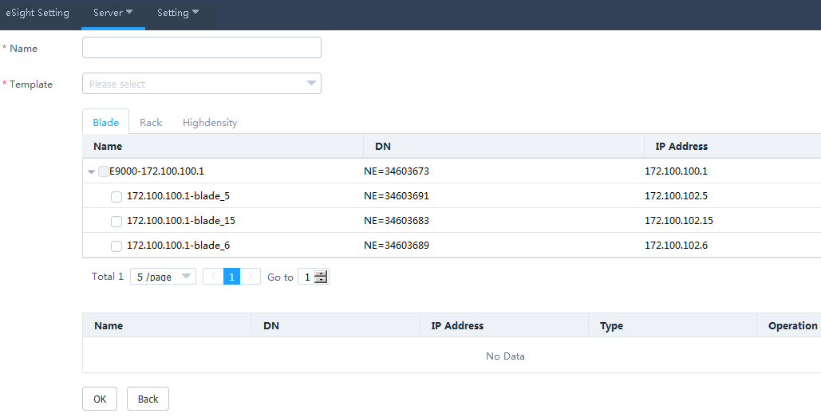

- Name: name of the task
- Template: name of the created template. Also select the server to which the template is to be added.
The Prompt dialog box is displayed.
            - Click OK.
The task is created.
On the Task Management page, view the created task, as shown in Figure 1-1.
              - Task Management
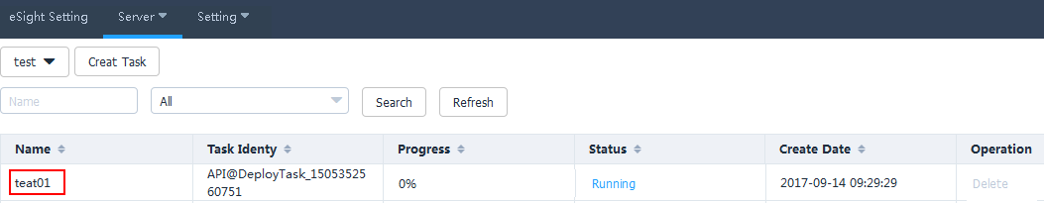

When the value of Progress changes to 100%, check the status value in Status to view the template task operation result, as shown in Figure 1-2.
              - Details about Deployed Devices
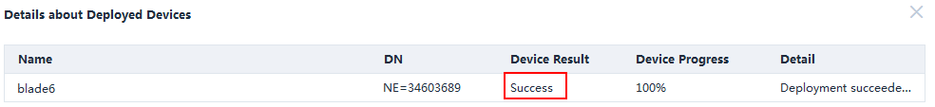

- Click Refresh to view the template task progress.
- To delete a template task, click Delete in the row of the template task to be deleted.
----End

Managing Templates

Configuring Power Control
            - On the vCenter WebUI, choose Home > Operations and Policies > Huawei vCenter Plugin.
The Huawei vCenter Plugin page is displayed.
            - Choose Server > Template Management.
The Template Management page is displayed.
            - Click Create Template.
The page for creating a template is displayed.
            - Set the following parameters, and click OK, as shown in Figure 1-1.
              - Adding a power control template
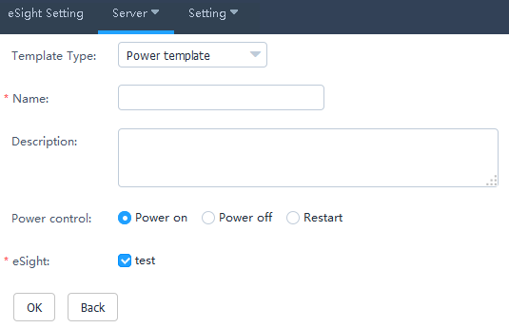

- Template Type: Select Power template.
- Name: Set this parameter to a customized name. This parameter is used to identify the power control template.
- Description: (Optional) Set this parameter to customized description, which provides supplementary information for the power control template.
- Power control: Select Power on, Power off, or Restart.
- eSight: Select the eSight based on the actual requirements. You can select multiple eSight systems.
The Prompt dialog box is displayed.
            - Click OK.
The power control template is created.
On the Template Management page, view the created power control template.
To delete a template, click Delete in the row of the template to be deleted.
            - Create a template task. For details, see 3.2.2.3 Creating a Template Task.
----End

Configuring the BIOS
            - On the vCenter WebUI, choose Home > Operations and Policies > Huawei vCenter Plugin.
The Huawei vCenter Plugin page is displayed.
            - Choose Server > Template Management.
The Template Management page is displayed.
            - Click Create Template.
The page for creating a template is displayed.
            - Set the following parameters, as shown in Figure 1-1.
              - Adding a BIOS template
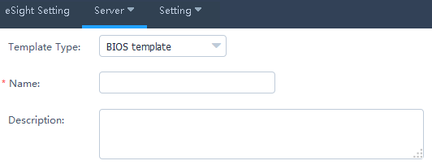

- Template Type: Select BIOS template.
- Name: Set this parameter to a customized name. This parameter is used to identify the BIOS template.
- Description: (Optional) Set this parameter to customized description, which provides supplementary information for the BIOS template.
            - In the Boot area, use or to set the system boot sequence.
            - In the Virtualization area, set the parameters described in Table 1-1, as shown in Figure 1-1.
              - Virtualization

                - Parameters in the Virtualization area
Parameter | Description
VT support | Enables or disables the hardware-assisted virtualization technology.  - Enabled: enables the hardware-assisted virtualization technology.  - Disabled: disables the hardware-assisted virtualization technology.  - Default: retains the default settings.
PCIe SR-IOV | Enables or disables the SR-IOV technology of the PCIe card.  - Enabled: enables the SR-IOV technology of the PCIe card.  - Disabled: disables the SR-IOV technology of the PCIe card.  - Default: retains the default settings.

            - In the Advanced Processor area, set the parameters described in Table 1-1, as shown in Figure 1-1.
              - Advanced Processor
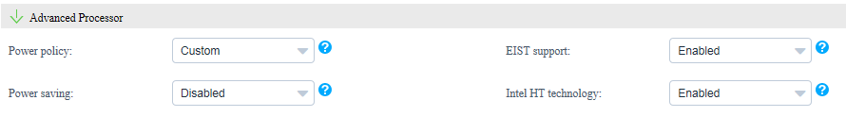

                - Parameters in the Advanced Processor area
Parameter | Description
Power policy | Indicates the power policy.  - Efficient: indicates the mode of low performance and low power consumption. This mode can reduce the power consumption of the system.  - Performance: indicates the mode of high performance and high power consumption.  - Custom: indicates the mode that reduces the power consumption of most OSs and applications and minimizes the impact on performance.  - Default: retains the default settings.
EIST support | Indicates the intelligent frequency control function.  - Enabled: enables the EIST function.  - Disabled: disables the EIST function.  - Default: retains the default settings.
Power saving | Indicates the CPU P State adjustment function.  - Enabled: enables the CPU P State adjustment function.  - Disabled: disables the CPU P State adjustment function.  - Default: retains the default settings.
Intel HT technology | Indicates the Intel Hyper Threading (HT) technology. This technology enhances CPU performance by increasing the number of CPU kernel threads.  - Enabled: enables the CPU HT function.  - Disabled: disables the CPU HT function.  - Default: retains the default settings.

            - In the IPMI area, set the parameters described in Table 1-1, as shown in Figure 1-1.
              - IPMI

                - Parameters in the IPMI area
Parameter | Description
Restore on AC Power Loss | Indicates the restoration mode used by the BMC after AC power-off.  - Power OFF: powers off the system.  - Last State: restores the system to the last state.  - Power ON: powers on the system.  - Default: retains the default settings.

            - Click Advanced.
The Advanced Settings dialog box is displayed.
            - In the Boot area, set the parameters described in Table 1-1, as shown in Figure 1-1.
              - Boot
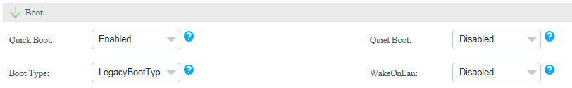

                - Parameters in the Boot area
Parameter | Description
Quick Boot | Indicates the quick boot mode.  - Enabled: enables the quick boot mode.  - Disabled: disables the quick boot mode.  - Default: retains the default settings.
Quiet Boot | Indicates the quiet boot mode.  - Enabled: enables the quiet boot mode.  - Disabled: disables the quiet boot mode.  - Default: retains the default settings.
Boot Type | Indicates the system boot mode.  - Dual Boot Type: supports both the Legacy boot mode and the UEFI boot mode.  - Legacy Boot Type: supports only the Legacy boot mode.  - UEFI Boot Type: supports only the UEFI boot mode.  - Default: retains the default settings.
WakeOnLan | Indicates the remote startup of a server when it receives a special data packet.  - Enabled: enables the Wake On Lan function.  - Disabled: disables the Wake On Lan function.  - Default: retains the default settings.

            - In the Virtualization area, set the parameters described in Table 1-1, as shown in Figure 1-1.
              - Virtualization
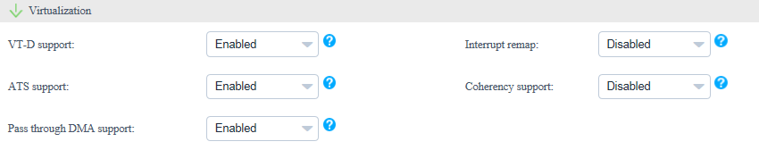

                - Parameters in the Virtualization area
Parameter | Description
VT-D support | Indicates the direct I/O virtualization function.  - Enabled: enables the direct I/O virtualization function.  - Disabled: disables the direct I/O virtualization function.  - Default: retains the default settings.
Interrupt remap | Indicates the interrupt remapping function.  - Enabled: enables the interrupt remapping function.  - Disabled: disables the interrupt remapping function.  - Default: retains the default settings.
ATS support | Indicates the ATS function.  - Enabled: enables the ATS function.  - Disabled: disables the ATS function.  - Default: retains the default settings.
Coherency support | Indicates the Coherency Support function.  - Enabled: enables the Coherency Support function.  - Disabled: disables the Coherency Support function.  - Default: retains the default settings.
Pass through DMA support | Indicates the PassThrough DMA function.  - Enabled: enables the PassThrough DMA function.  - Disabled: disables the PassThrough DMA function.  - Default: retains the default settings.

            - In the Advanced Processor area, set the parameters described in Table 1-1, as shown in Figure 1-1.
              - Advanced Processor
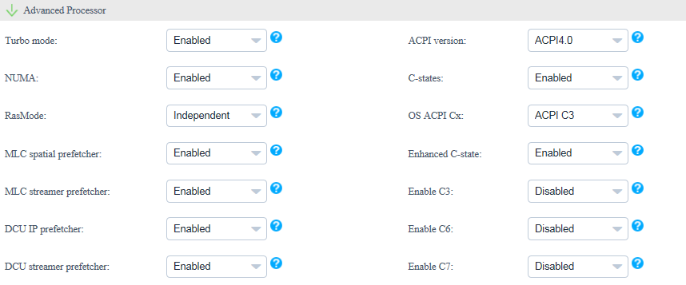

                - Parameters in the Advanced Processor area
Parameter | Description
Turbo mode | Indicates the dynamic acceleration function.  - Enabled: enables the dynamic acceleration function.  - Disabled: disables the dynamic acceleration function.  - Default: retains the default settings.
ACPI version | Indicates the ACPI version.  - ACPI1.0B: ACPI1.0B version  - ACPI3.0: ACPI3.0 version  - ACPI4.0: ACPI4.0 version  - Default: retains the default settings.
NUMA | Indicates the non-uniform memory access (NUMA) function.  - Enabled: enables the NUMA function.  - Disabled: disables the NUMA function.  - Default: retains the default settings.
C-states | Indicates the CPU C status control function.  - Enabled: enables the CPU C status control function.  - Disabled: disables the CPU C status control function.  - Default: retains the default settings.
RasMode | Indicates the memory RAS mode.  - Independent  - Mirror  - LockStep  - RankSpare  - LockStepAndRankSpare  - Default
OS ACPI Cx | Indicates the Advanced Configuration and Power Interface (ACPI) C-state of the OS. The OS instructs a CPU to enter the C-state based on the ACPI C-state.  - ACPI C2  - ACPI C3  - Default
MLC spatial prefetcher | Indicates the Mid Level Cache (MLC) Spatial prefetcher function.  - Enabled: enables the MLC Spatial prefetcher function.  - Disabled: disables the MLC Spatial prefetcher function.  - Default: retains the default settings.
Enhanced C-state | Indicates the C-state function.  - Enabled: enables the C-state function.  - Disabled: disables the C-state function.  - Default: retains the default settings.
MLC streamer prefetcher | Indicates the MLC Streamer prefetcher function.  - Enabled: enables the MLC Streamer prefetcher function.  - Disabled: disables the MLC Streamer prefetcher function.  - Default: retains the default settings.
Enable C3 | Indicates the C3 function.  - Enabled: enables the C3 function.  - Disabled: disables the C3 function.  - Default: retains the default settings.
DCU IP prefetcher | Indicates the data cache unit (DCU) IP prefetcher function. This function determines whether to prefetch data based on historical records. This function is enabled by default. You can enable or disable this function based on the applications running on the server. This function can affect performance and shorten the data reading time.  - Enabled: enables the DCU IP prefetcher function.  - Disabled: disables the DCU IP prefetcher function.  - Default: retains the default settings.
Enable C6 | Indicates the C6 function.  - Enabled: enables the C6 function.  - Disabled: disables the C6 function.  - Default: retains the default settings.
DCU streamer prefetcher | Indicates the DCU streamer prefetcher function. This function can be used to preread CPU data. This function is enabled by default. You can enable or disable this function based on the applications running on the server. This function can affect performance and shorten the data reading time.  - Enabled: enables the DCU streamer prefetcher function.  - Disabled: disables the DCU streamer prefetcher function.  - Default: retains the default settings.
Enable C7 | Indicates the C7 function.  - Enabled: enables the C7 function.  - Disabled: disables the C7 function.  - Default: retains the default settings.

            - In the Console Serial Port area, set the parameters described in Table 1-1, as shown in Figure 1-1.
              - Console Serial Port
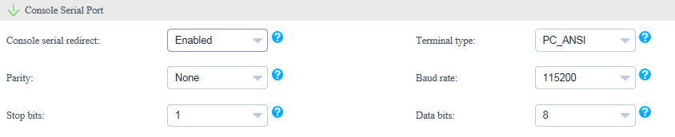

                - Parameters in the Console Serial Port area
Parameter | Description
Console serial redirect | Indicates the serial port redirection function.  - Enabled: enables the serial port redirection function.  - Disabled: disables the serial port redirection function.  - Default: retains the default settings.
Terminal type | Indicates the terminal protocol.  - VT_100  - VT_100+  - VT_UTF8  - PC_ANSI  - Default
Parity | Indicates the parity check function.  - None: indicates no parity check.  - Even: indicates the even parity check.  - Odd: indicates the odd parity check.  - Default: retains the default settings.
Baud rate | Indicates the serial port redirection speed.  - 115200  - 57600  - 19200  - 9600  - Default
Stop bits | Indicates the stop bit for the serial port redirection function.  - 1  - 2  - Default
Data bits | Indicates the data bit length for the serial port redirection function.  - 7  - 8  - Default

            - In the IPMI area, set the parameters described in Table 1-1, as shown in Figure 1-1.
              - IPMI
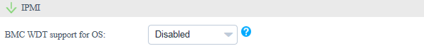

                - Parameters in the IPMI area
Parameter | Description
BMC WDT support for OS | Indicates the watchdog during the OS startup process.  - Enabled: enables the watchdog during the OS startup process.  - Disabled: disables the watchdog during the OS startup process.  - Default: retains the default settings.

            - Click OK.
            - Select the eSight to which the BIOS template is to be added, and click OK. (You can select multiple eSight systems.)
The Prompt dialog box is displayed.
            - Click OK.
The BIOS template is created.
On the Template Management page, view the created BIOS template.
To delete a template, click Delete in the row of the template to be deleted.
            - Create a template task. For details, see 3.2.2.3 Creating a Template Task.
----End

Configuring an HBA
            - On the vCenter WebUI, choose Home > Operations and Policies > Huawei vCenter Plugin.
The Huawei vCenter Plugin page is displayed.
            - Choose Server > Template Management.
The Template Management page is displayed.
            - Click Create Template.
The page for creating a template is displayed.
            - Set the following parameters, as shown in Figure 1-1.
              - Adding an HBA template
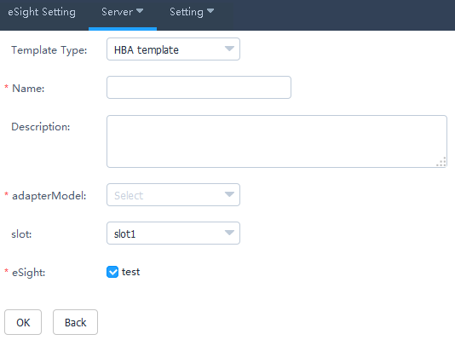

- Template Type: Select HBA template.
- Name: Set this parameter to a customized name. This parameter is used to identify the HBA template.
- Description: (Optional) Set this parameter to customized description, which provides supplementary information for the HBA template.
- Adapter Model: Select the HBA model.
- slot: Select the HBA slot number.
- eSight: Select the eSight based on the actual requirements. You can select multiple eSight systems.
            - In the port area, click Advanced.
The Advanced dialog box is displayed.
            - Set the following parameters, and click OK, as shown in Figure 1-1.
              - Advanced
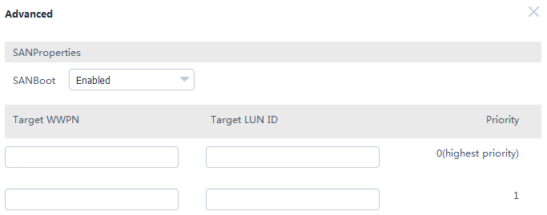

- SAN boot: Select Enabled or Disabled.
- Target WWPN: This parameter needs to be set only when SAN boot is set to Enabled.
- Target LUN ID: This parameter needs to be set only when SAN boot is set to Enabled.
- Target WWNN: This parameter needs to be set only when SAN boot is set to Enabled and Adapter Model is set to QLE2560 or QLE2562.
            - Click OK.
The Prompt dialog box is displayed.
            - Click OK.
The HBA template is created.
On the Template Management page, view the created HBA template.
To delete a template, click Delete in the row of the template to be deleted.
            - Create a template task. For details, see 3.2.2.3 Creating a Template Task.
----End

Configuring RAID
            - On the vCenter WebUI, choose Home > Operations and Policies > Huawei vCenter Plugin.
The Huawei vCenter Plugin page is displayed.
            - Choose Server > Template Management.
The Template Management page is displayed.
            - Click Create Template.
The page for creating a template is displayed.
            - Set the following parameters, as shown in Figure 1-1.
              - Adding a RAID template
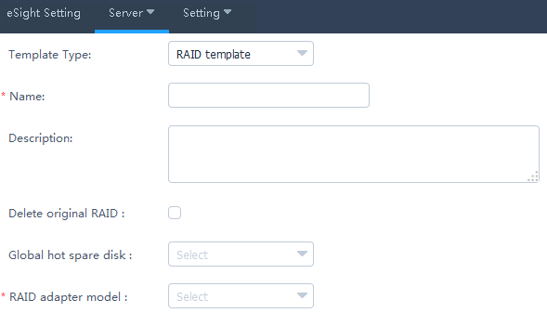

- Template Type: Select RAID template.
- Name: Set this parameter to a customized name. This parameter is used to identify the RAID template.
- Description: (Optional) Set this parameter to customized description, which provides supplementary information for the RAID template.
- Delete original RAID: This parameter is deselected by default. Determine whether to select this parameter based on the actual situation.
- Global hot spare disk: (Optional) This parameter is not set by default. Select the slot number of the hard disk to be set to a global hot spare disk. You can select multiple slot numbers.
- RAID adapter model: Select the model of the RAID adapter to be configured.
            - In the RAID Group area, click Create.
The Create RAID Group dialog box is displayed.
            - Set the following parameters, and click OK, as shown in Figure 1-1.
              - Create RAID Group
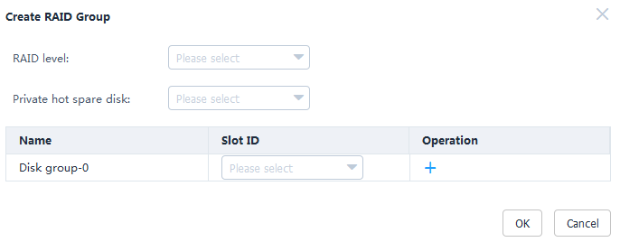

- RAID level: Select the RAID level to be configured.
- Private hot spare disk: (Optional) This parameter is not set by default. Select the slot number of the hard disk to be set to a private hot spare disk. You can select multiple slot numbers.
- Private hot spare disks cannot be configured for RAID 0.
- Private hot spare disks cannot be configured for LSI SAS2308 and LSI SAS3008.
- Disk group-0: Select the slot number of the hard disk to be added to the hard disk group.
Only one disk group can be created for RAID 0, RAID 1, RAID 5, RAID 6, and RAID 1E.
            - (Optional) Retain the default value 0 for Start LUN ID.
            - Click OK.
The Prompt dialog box is displayed.
            - Click OK.
The RAID template is created.
On the Template Management page, view the created RAID template.
To delete a template, click Delete in the row of the template to be deleted.
            - Create a template task. For details, see 3.2.2.3 Creating a Template Task.
----End

Configuring a CNA
            - On the vCenter WebUI, choose Home > Operations and Policies > Huawei vCenter Plugin.
The Huawei vCenter Plugin page is displayed.
            - Choose Server > Template Management.
The Template Management page is displayed.
            - Click Create Template.
The page for creating a template is displayed.
            - Set the following parameters, as shown in Figure 1-1.
              - Adding a CNA template
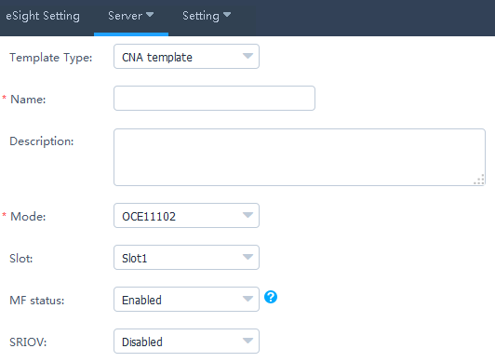

- Template Type: Select CNA template.
- Name: Set this parameter to a customized name. This parameter is used to identify the CNA template.
- Description: (Optional) Set this parameter to customized description, which provides supplementary information for the CNA template.
- Mode: Select the CNA model.
- Slot: (Optional) Select the CNA slot number.
- MF status: (Optional) This parameter needs to be set only when Mode is set to OCE11102, MZ510, or MZ512. Determine whether to enable MF based on the actual situation.
- SRIOV: (Optional) This parameter needs to be set only when Mode is set to OCE11102, MZ510, or MZ512. Determine whether to enable SRIOV based on the actual situation.
MF and SRIOV cannot be enabled at the same time.
            - Check whether Mode is set to MZ910.
- If yes, perform Step 6 and Step 7.
- If no, go to Step 8.
            - In the port area, click Advanced.
The Advanced dialog box is displayed.
            - Enable or disable PXE boot, and click OK.
Then go to Step 11.
            - In the port area, set the parameters described in Table 1-1.
                - Port0
Parameter | Description
PF type | - NIC  - iSCSI  - FCoE  NOTE  iSCSI and FCoE are available only for PF1.
PF VLAN ID | This parameter needs to be set if PF type is set to NIC. Enter a VLAN ID based on the actual situation.

            - In the port area, click Advanced.
The Advanced dialog box is displayed.
            - Set the parameters described in Table 1-1, as shown in Figure 1-1.
              - Advanced
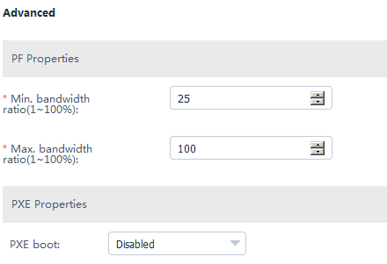

                - Parameters in the Advanced dialog box
Parameter | Description
Min. bandwidth ratio | Indicates the minimum bandwidth ratio of a single virtual network port.
Max. bandwidth ratio | Indicates the maximum bandwidth ratio of a single virtual network port.
PXE boot | This parameter can be set to Enabled or Disabled.

            - Click OK.
The Prompt dialog box is displayed.
            - Click OK.
The CNA template is created.
On the Template Management page, view the created CNA template.
To delete a template, click Delete in the row of the template to be deleted.
            - Create a template task. For details, see 3.2.2.3 Creating a Template Task.
----End

Configuring the iBMC
            - On the vCenter WebUI, choose Home > Operations and Policies > Huawei vCenter Plugin.
The Huawei vCenter Plugin page is displayed.
            - Choose Server > Template Management.
The Template Management page is displayed.
            - Click Create Template.
The page for creating a template is displayed.
            - Set the following parameters, as shown in Figure 1-1.
              - Adding an iBMC template
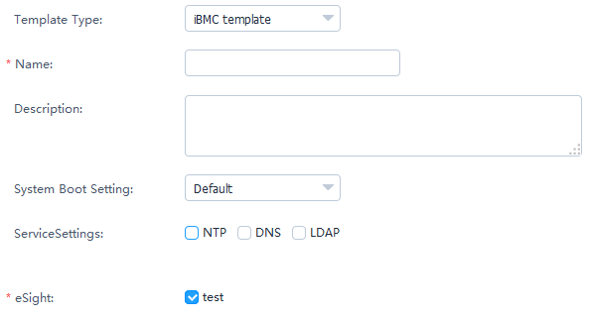

- Template Type: Select iBMC template.
- Name: Set this parameter to a customized name. This parameter is used to identify the iBMC template.
- Description: (Optional) Set this parameter to customized description, which provides supplementary information for the iBMC template.
- System Boot Setting: Select a system boot option based on the actual situation.
- Service Settings: Select a service setting option based on the actual situation. You can select multiple options. After NTP, DNS, or LDAP is selected, the related parameters need to be set.
- eSight: Select the eSight based on the actual requirements. You can select multiple eSight systems.
            - In the NTP area, set the parameters described in Table 1-1, as shown in Figure 1-1.
              - NTP
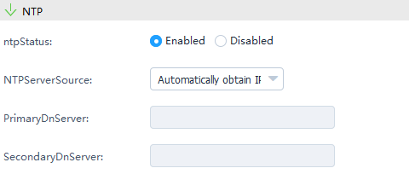

                - Parameters in the NTP area
Parameter | Description
NTP Status | Enable or disable NTP.  - Enabled  - Disabled
NTP Server Source | Select the NTP server source obtaining mode.  - Automatically obtain IPv4  - Automatically obtain IPv6  - Manually obtain
Primary NTP Server | (Optional) Enter the preferred NTP server IP address only when the NTP server source is obtained manually.
Secondary NTP Server | (Optional) Enter the alternate NTP server IP address only when the NTP server source is obtained manually.

            - In the DNS area, set the parameters described in Table 1-1.
                - Parameters in the DNS area
Parameter | Description
DNS Source | Select the DNS obtaining mode.  - Automatically Obtain  - Manually Set
Domain Name | (Optional) Set the domain name only when the DNS is set manually.
Primary DNS Server | (Optional) Set the preferred DNS server IP address only when the DNS is set manually.
Secondary DNS Server | (Optional) Set the alternate DNS server IP address only when the DNS is set manually.

            - In the LDAP area, set the parameters described in Table 1-1, as shown in Figure 1-1.
              - LDAP
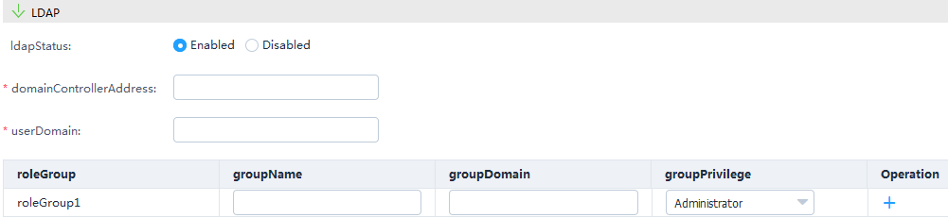

                - Parameters in the LDAP area
Parameter | Description
LDAP Status | Select the LDAP status.  - Enabled  - Disabled
Domain Controller Address | (Optional) Set the domain controller address only when LDAP is enabled.
User Domain | (Optional) Set the user domain only when LDAP is enabled.
Role Group | (Optional) Set the group name, group domain, and group privilege only when LDAP is enabled.  NOTE  You need to configure at least one role group. A maximum of five role groups can be configured.

            - Click OK.
The Prompt dialog box is displayed.
            - Click OK.
The iBMC template is created.
On the Template Management page, view the created iBMC template.
To delete a template, click Delete in the row of the template to be deleted.
            - Create a template task. For details, see 3.2.2.3 Creating a Template Task.
----End

Upgrading the Firmware and Driver

Uploading an Upgrade Package
Prerequisites
The SFTP server for uploading the upgrade package has been set up.
Procedure
            - Upload an upgrade package and the corresponding digital signature file to the SFTP server.
            - On the vCenter WebUI, choose Home > Operations and Policies > Huawei vCenter Plugin.
The Huawei vCenter Plugin page is displayed.
            - Choose Server > Firmware Upload.
The Firmware Upload page is displayed.
            - Click Add.
The page for adding a file is displayed.
            - Set the following parameters, and click OK, as shown in Figure 1-1.
              - Uploading an upgrade package
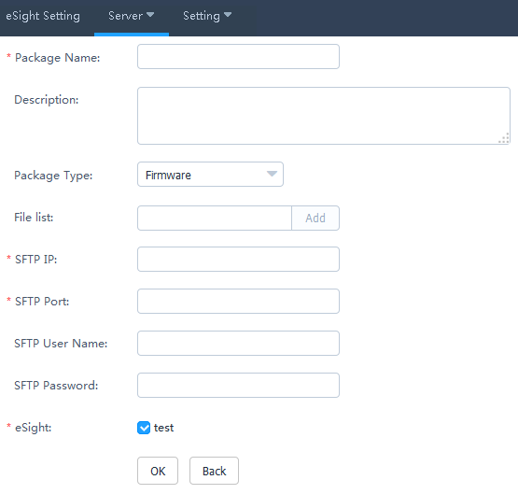

- Package Name: upgrade package name
- Description: upgrade package description
- Package Type: type of the upgrade package, which can be Firmware, Driver, or Bundle.
- File list: upgrade package file and digital signature file. Enter the upgrade package name, and click Add. Then enter the digital signature file name, and click Add.
For firmware and driver packages, ZIP and digital signature certificates must be uploaded. For bundle packages, only ZIP packages need to be uploaded.
- SFTP IP: SFTP server IP address
- SFTP Port: SFTP server port number
- SFTP Name: SFTP server user name
- SFTP Password: SFTP server password
- eSight: name of the eSight for which you want to upload an upgrade package. You can select multiple eSight systems at the same time.
The Prompt dialog box is displayed.
            - Click OK.
The firmware upload task is created.
On the Firmware Upload page, view the created firmware uploading task, as shown in Figure 1-1.
              - Firmware Upload
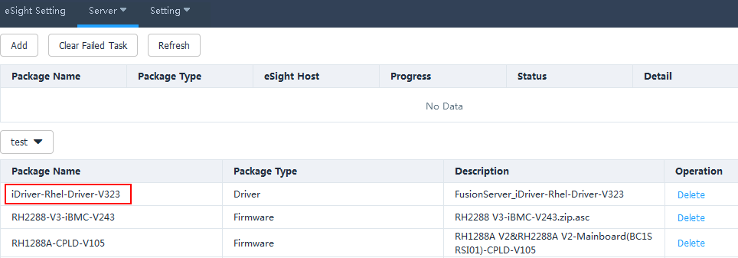

- Click Refresh to view the firmware uploading progress.
- When the value of Progress changes to 100%, check the status value in Status to view the package uploading result.
- To delete an upgrade package that fails to be uploaded, click Clear Failed Task. All upgrade packages that fail to be uploaded will be deleted.
- To delete an upgrade package that is successfully uploaded, click Delete in the row of the upgrade package.
----End

Upgrading the Firmware and Driver
Prerequisites
You have installed iBMA 2.0.0 or later on the OS of the managed server. You can log in to Huawei Enterprise support website and choose Support > Servers > Server Management Software > iBMA to obtain the software.
Procedure
            - On the vCenter WebUI, choose Home > Operations and Policies > Huawei vCenter Plugin.
The Huawei vCenter Plugin page is displayed.
            - Choose Server > Firmware Upgrade.
The Firmware Upgrade page is displayed.
            - Click Create Task.
The page for adding a task is displayed.
            - Set the following parameters, and click OK, as shown in Figure 1-1.
              - Creating an upgrade task
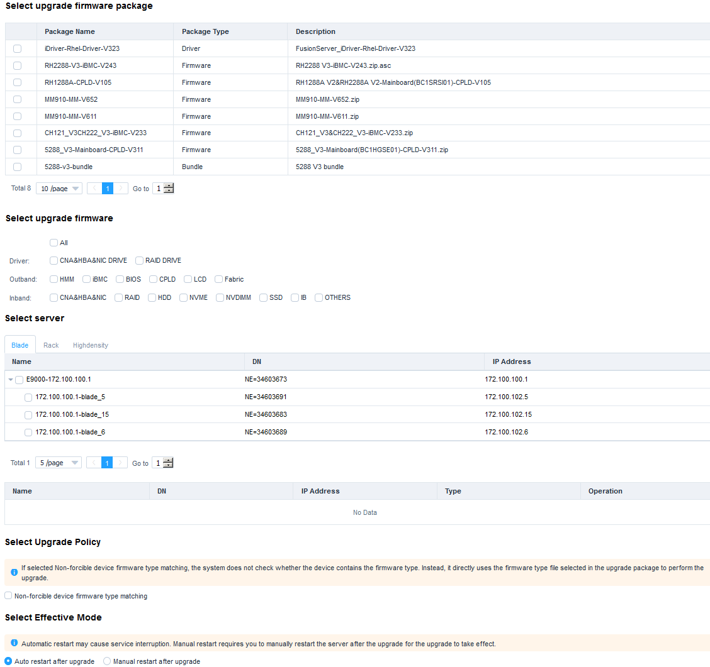

- Select upgrade firmware package: name of the firmware package to be upgraded
- Select upgrade firmware: firmware to be upgraded
- Select server: server to be upgraded
- Select Upgrade Policy: Non-forcible device firmware type matching is deselected by default.
- Select Effective Mode: Auto restart after upgrade is selected by default.
The Prompt dialog box is displayed.
            - Click OK.
The upgrade task is created.
On the Firmware Upgrade page, view the created firmware upgrade task, as shown in Figure 1-1.
              - Firmware Upgrade
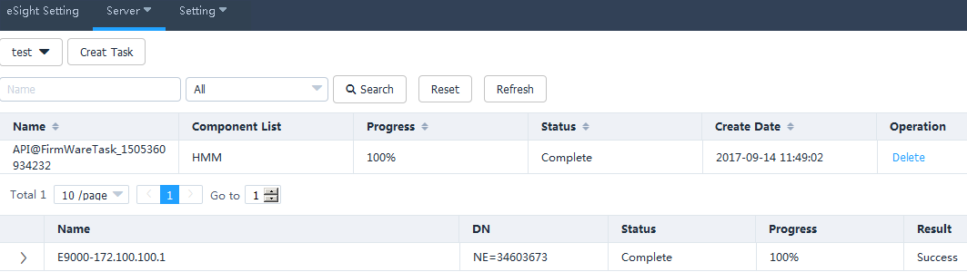

- Click Refresh to view the firmware and driver upgrade progress.
- When the value of Progress changes to 100%, check the status value in Status to view the firmware and driver upgrade result.
- To delete a firmware and driver upgrade task, click Delete in the row of the firmware and driver upgrade task.
----End

Registering, Configuring, and Using Proactive HA

Registering the HA Provider
- The ESXi system has been installed on the target server, and the ESXi system has been added to the vCenter cluster. For details, see 4.4 How to Add a Server ESXi System to a vCenter Cluster.
- The target server has been added to eSight, and eSight has been added to the Huawei vCenter plug-in.
- After the HA Provider is registered, if you need to add another host to the cluster, you need to add it to Datacenter, register the HA Provider again, and move the host to the cluster.
            - On the vCenter WebUI, choose Home > Operations and Policies > Huawei vCenter Plugin.
The Huawei vCenter Plugin page is displayed, as shown in Figure 1-1.
              - Huawei vCenter plug-in
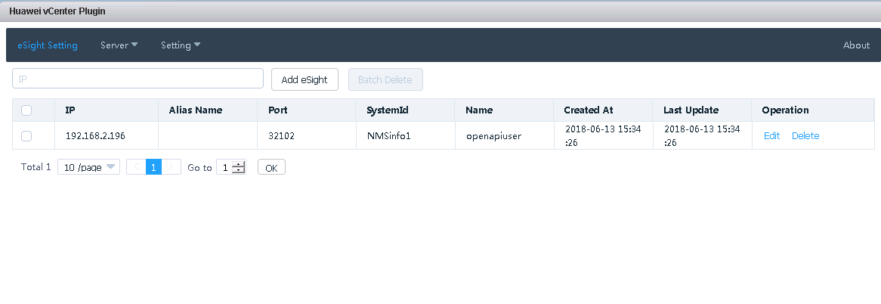

            - Choose Setting > HA Setting.
The HA setting page is displayed, as shown in Figure 1-1.
              - Registering the HA Provider
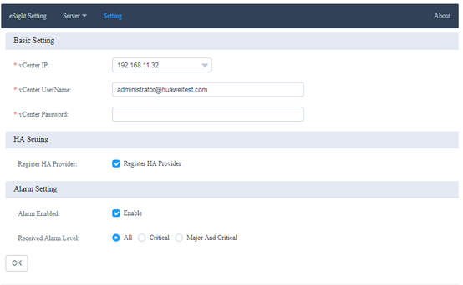

            - Select Register HA Provider, enter the IP address, user name, and password of the current vCenter, and click OK.
The HA Provider registration starts. After the registration is successful, a dialog box is displayed, as shown in Figure 1-1.
              - Successful registration
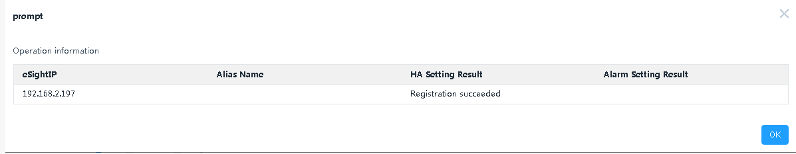

            - Click OK.
The HA Provider is registered.
----End

Configuring Proactive HA
            - On the vCenter WebUI, choose Home > Inventories > Hosts and Clusters.
The Hosts and Clusters page is displayed.
            - Click the cluster where the target host is located, and click Configure.
The page for configuring Proactive HA is displayed, as shown in Figure 1-1.
              - Configuring Proactive HA
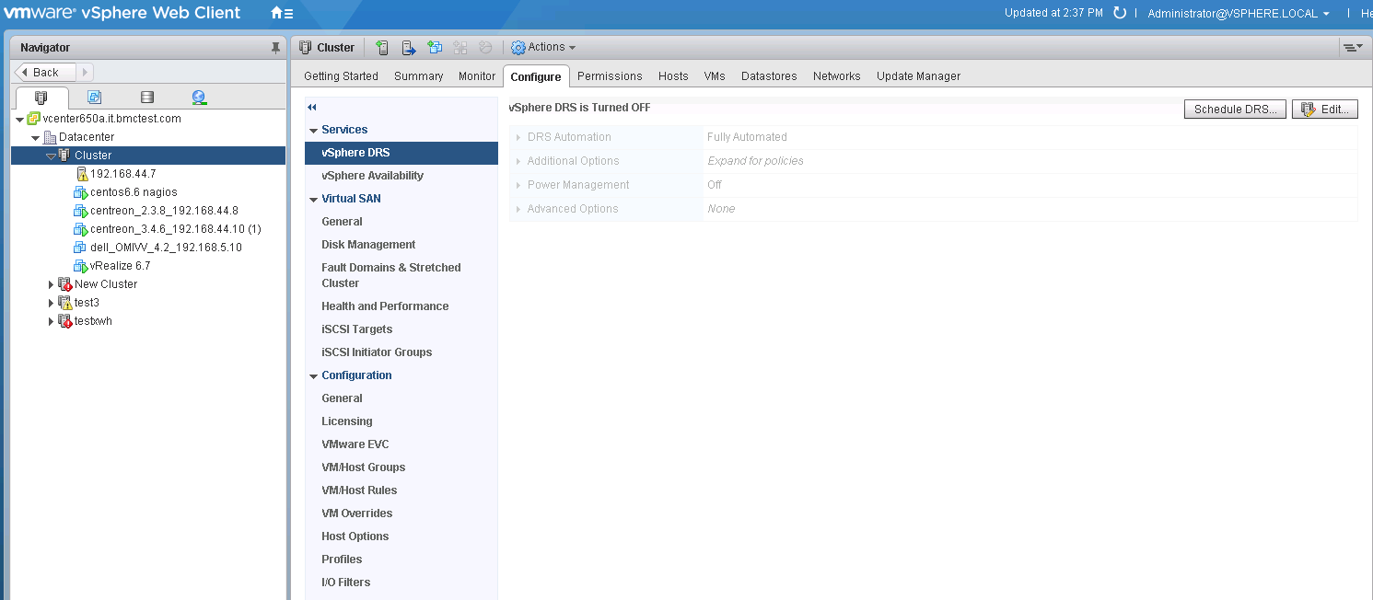

            - Click Edit in the upper right corner.
The Edit Cluster Setting page is displayed, as shown in Figure 1-1.
              - Edit Cluster Setting
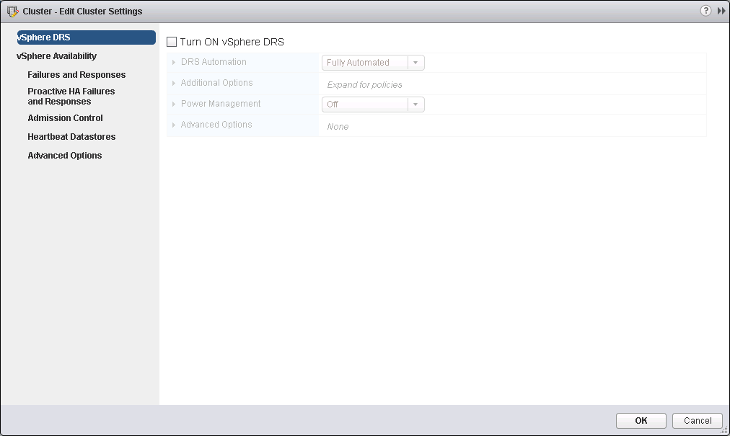

            - Select Turn ON vSphere DRS.
            - Click vSphere Availability.
The vSphere Availability page is displayed, as shown in Figure 1-1.
              - vSphere Availability
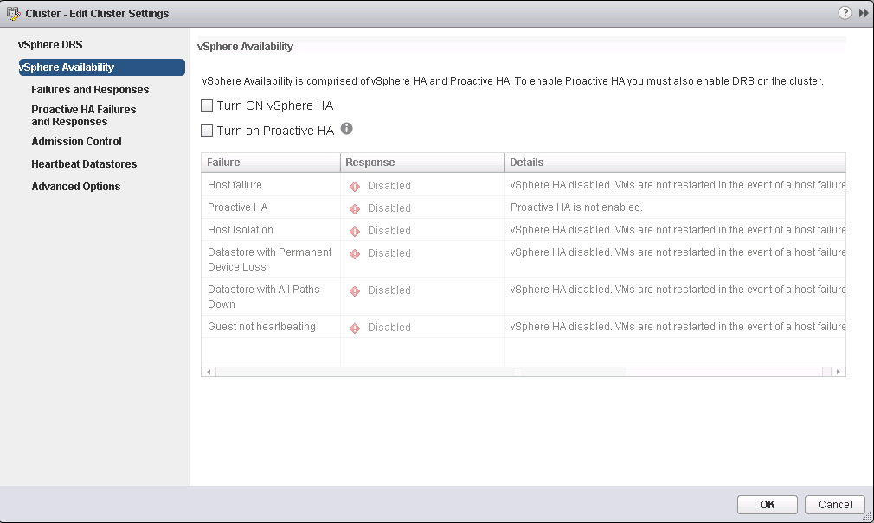

            - Select Turn ON vSphere HA and Turn on Proactive HA.
            - Click Failures and Responses.
The Failures and Responses page is displayed, as shown in Figure 1-1.
              - Failures and Responses
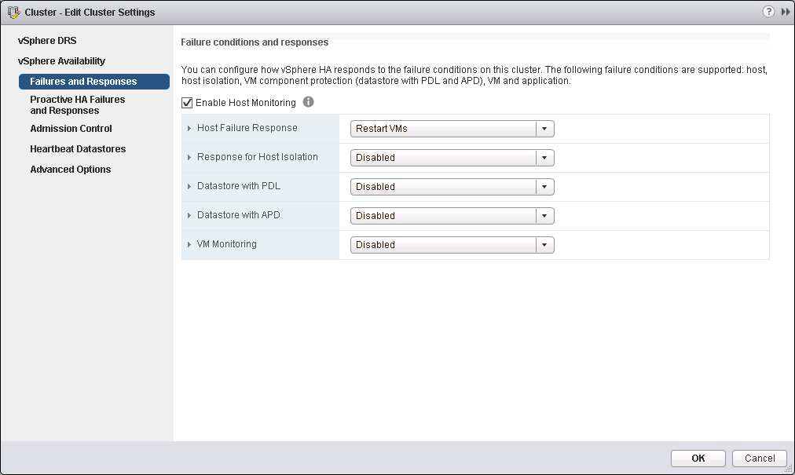

            - Select Enable Host Monitoring.
            - Click Proactive HA Failures and Responses.
The Proactive HA Failures and Responses page is displayed, as shown in Figure 1-1.
              - Proactive HA Failures and Responses
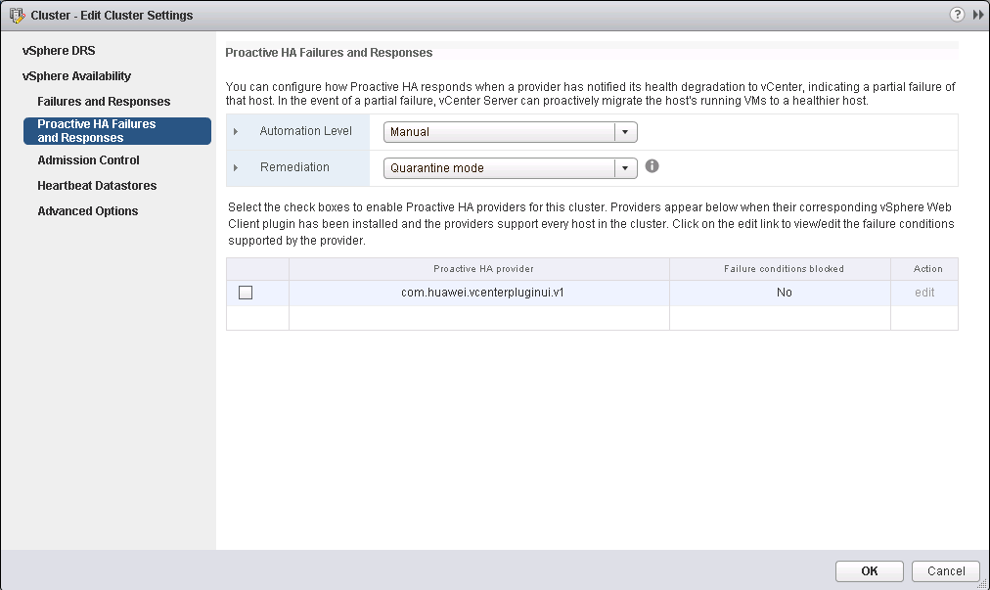

            - In the Proactive HA provider table, select the provider program com.huawei.vcenterpluginui.v1 provided by the Huawei vCenter plug-in, and click OK.
Proactive HA is configured.
----End

Using Proactive HA
            - On the vCenter WebUI, choose Home > Inventories > Hosts and Clusters.
The Hosts and Clusters page is displayed.
            - Choose Datacenter > Cluster > Host.
The host page is displayed, as shown in Figure 1-1.
              - Host
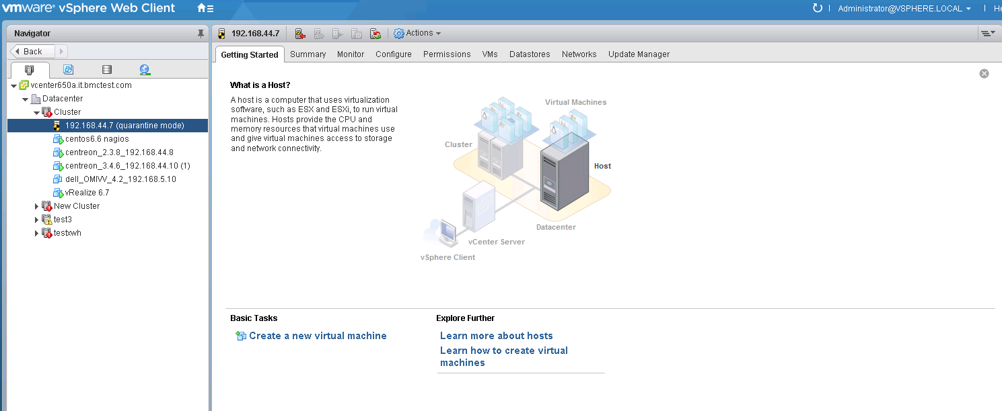

            - Choose Monitor > Tasks & Events > Events.
The event page of the server is displayed, as shown in Figure 1-1. You can view the alarms pushed by HA Provider. The alarm description is started with the HA Provider name.
              - Events
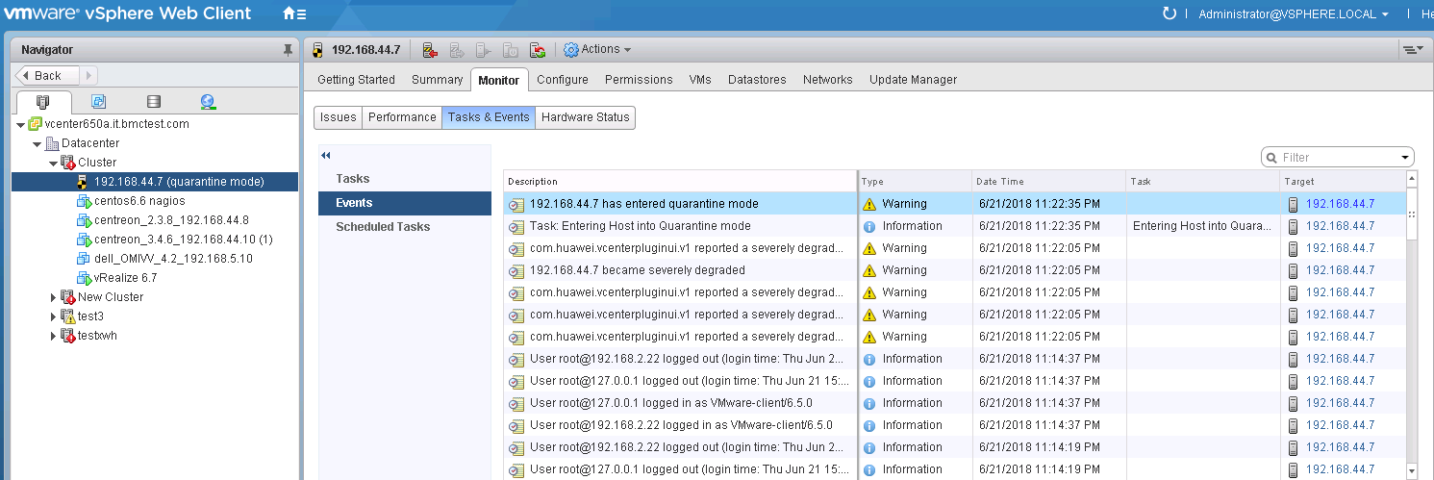

If Automation Level is set to Automated and Remediation is set to Quarantine mode in 3.2.5.2 Configuring Proactive HA, as shown in Figure 1-2, when the alarms pushed by HA Provider are severely degraded, vCenter will isolate the host.
              - Configuring Proactive HA
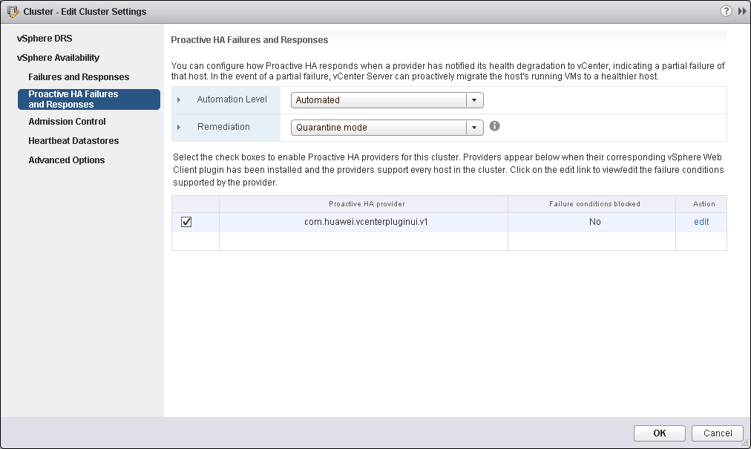

----End

Receiving and Viewing Server Alarms
            - On the vCenter WebUI, choose Home > Operations and Policies > Huawei vCenter Plugin.
The Huawei vCenter Plugin page is displayed.
            - Choose Setting > Basic Setting.
The Basic Setting page is displayed, as shown in Figure 1-1.
Enter basic information.
              - Basic Setting

Basic Setting
- vCenter IP: Enter the vCenter IP address.
- vCenter UserName: Enter the vCenter administrator user name.
- vCenter Password: Enter the vCenter administrator password.
Alarm Setting
- Alarm Enabled: Determine whether to receive alarms.
- Received Alarm Level:
- All: Receive all events and alarms.
- Critical: Receive critical events and alarms.
- Major And Critical: Receive critical and major events and alarms.
            - Click OK. After information indicating that the configuration is successful is diaplayed, go to Step 4.
            - On the vCenter WebUI, choose Home > Inventories > Hosts and Clusters.
The Hosts and Clusters page is displayed.
            - Click the cluster where the target host is located to view events and alarms.
- Choose Monitor > Task & Events to view server events.
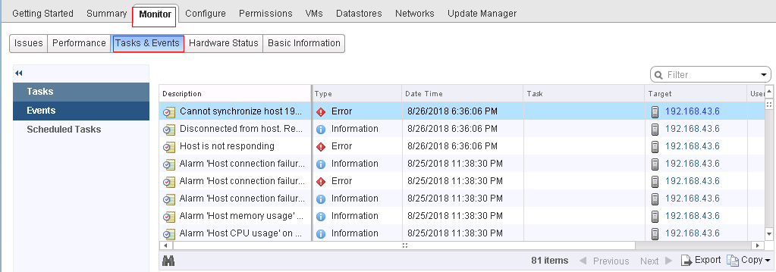
- Choose Monitor > Issues.
The problem description, alarm type, triggering time, and status information is displayed in the list.
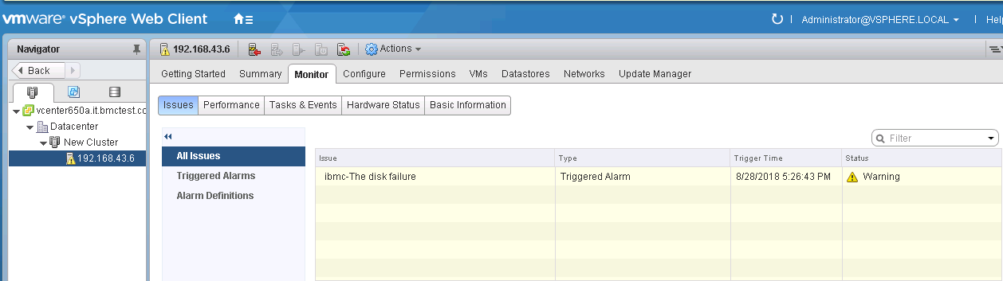
Click Triggered Alarms, and click the name of an alarm in the right list to view detailed alarm information.
              - Triggered Alarms
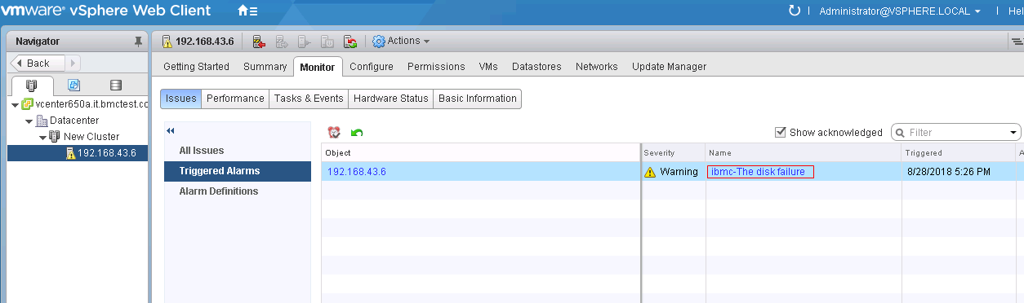

              - Detailed alarm information
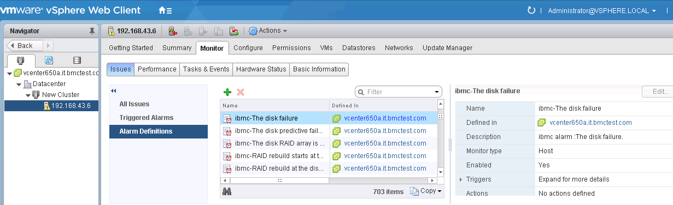

----End

Viewing the Huawei vCenter Plug-in Version
            - On the vCenter WebUI, choose Home > Operations and Policies > Huawei vCenter Plugin.
The Huawei vCenter Plugin page is displayed.
            - Click About.
View the Huawei vCenter plug-in version, as shown in Figure 1-1.
              - Huawei vCenter plug-in version


----End

FAQs
4.1 Connection Test Failed When Adding an eSight
4.2 Failed to Deploy an OS
4.3 Failed to Upload an Upgrade Package
4.4 How to Add a Server ESXi System to a vCenter Cluster

Connection Test Failed When Adding an eSight
Symptom
After an eSight server is added, a failure message is displayed during the connection test.
Cause
- The user name or password is incorrect.
- The eSight northbound interface user is locked.
- A whitelist has not been set.
Solution
- The user name or password is incorrect.
Enter the user name and password of the eSight northbound interface user. To view the user name and password, perform the following steps:
  - Log in to the eSight WebUI.
  - Choose System > User Management > User. The User page is displayed.
The role of the eSight northbound interface user is Open API user group, and the user name is displayed under User Name.
              - Viewing information about the eSight northbound interface user

  - Click to display the dialog box for resetting the user password.
              - Reset Password
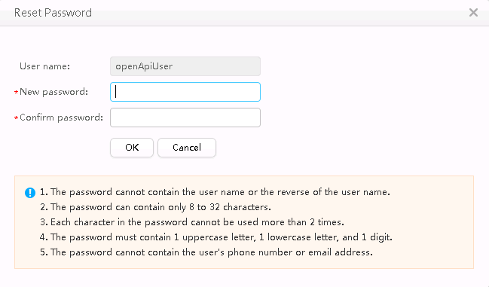

  - Enter a password in New password and Confirm password.
  - Click OK. The password is reset.
- The eSight northbound interface user is locked.
To unlock a user, perform the following steps:
  - Log in to the eSight WebUI.
  - Choose System > User Management > User.
The User page is displayed.
  - Click to set Status of the eSight northbound interface user to Enabled.
              - Unlocking a user

- A whitelist has not been set.
By default, a whitelist of eSight northbound ports is configured. To add an eSight properly, you must add the IP address of the server where vCenter is located to the whitelist of eSight northbound ports. To set the whitelist, perform the following steps:
  - Log in to the eSight WebUI.
  - Choose System > Northbound Integration > Third-party System > Create.
The Third-party System page is displayed, as shown in Figure 1-4.
              - Third-party System

  - Set the following parameters:
  - IP address: IP address of the vCenter server
  - Protocol type: HTTPS
  - System ID: Retain the default value or enter a new value. The value can be an IP address or a string of 1 to 64 characters, including digits (0-9), lowercase letters (a-z), uppercase letters (A-Z), and special characters @_- (), .^$~`!.
  - Click OK.
The IP address of the vCenter server is successfully added to the whitelist, as shown in Figure 1-5.
              - vCenter server successfully added to the whitelist

Failed to Deploy an OS
Symptom and Cause Analysis

Symptom | Cause Analysis
The message "Failed to mount ServiceCD" is displayed. | - The server is mounted and occupied by other virtual media.  - SNMP V3 protocol parameters of a server are incorrectly configured when the server is added to eSight.
The system displays a message indicating that the ServiceCD does not exist or the file name is incorrect. | The eSight installation path does not contain the ServiceCD software or the ServiceCD file name is incorrect.
Others | - No RAID is created in the RAID controller card.  - The server or RAID controller card does not support the deployed OS.

Solution
- The server is mounted and occupied by other virtual media.
Unmount the virtual media by performing the following steps:
  - Log in to iBMC WebUI.
  - Choose Remote Console > Virtual Media.
The Virtual Media page is displayed.
              - Virtual Media
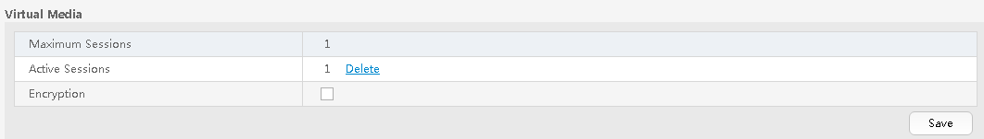

  - If the value of Active Sessions is 1, the virtual media has been mounted.
Click Delete. The Confirm dialog box is displayed.
              - Confirm
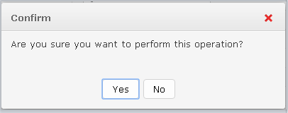

  - Select Yes to unmount the virtual media.
  - Perform the deployment task again. For details, see 3.2.2 Deploying an OS.
- SNMP V3 protocol parameters of a server are incorrectly configured when the server is added to eSight.
Check whether SNMP V3 parameters are correct.
  - Log in to the eSight WebUI.
  - Choose Resource > Server > Server Device > Rack Server.
The rack server page is displayed.
              - Rack server page
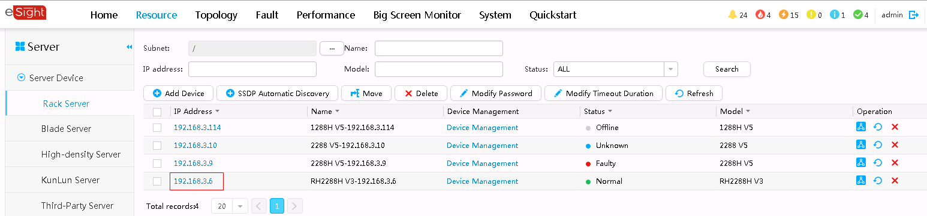

  - Select a server. The detailed server information is displayed.
  - Choose Settings > Protocol Parameters.
              - Viewing detailed server information
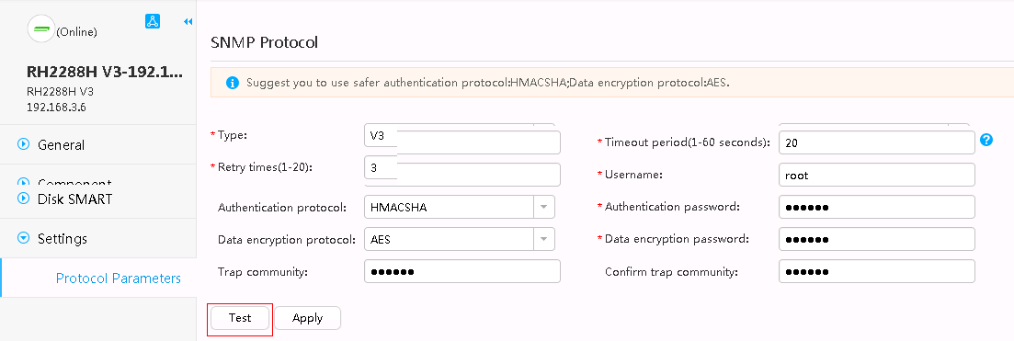

  - Click Test to test the SNMP protocol.
  - If the Succeeded dialog box is displayed, the SNMP protocol is correct.
  - If the Error dialog box is displayed, the SNMP protocol is incorrect. Enter correct SNMP V3 parameters.
              - SNMP Protocol
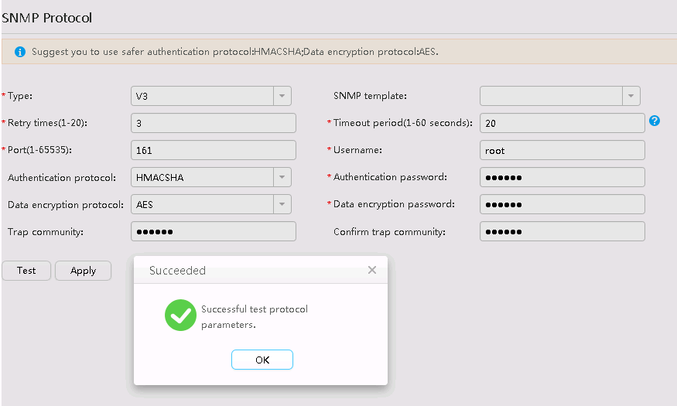

- The eSight installation path does not contain the ServiceCD software or the ServiceCD file name is incorrect.
  - Download the ServiceCD from the Software Download tab on the FusionServer Tools page at Huawei Enterprise support website.
  - Decompress the downloaded software package.
              - Decompressed ServiceCD software package
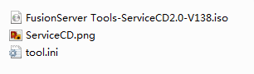

  - Change the name of the .iso file to FusionServer Tools-ServiceCD2.0-V110.iso.
  - Copy FusionServer Tools-ServiceCD2.0-V110.iso to eSight installation directory\AppBase\var\iemp\data\ftp\.
- No RAID is created in the RAID controller card.
For details about how to create a RAID, see 3.2.3.4 Configuring RAID.
- The server or RAID controller card does not support the deployed OS.
You can check the compatibility between the server, OS, and RAID controller card by using the Huawei Server Compatibility Checker.
Ensure that Note1 is present in the Notes column.
              - Checking the OS compatibility
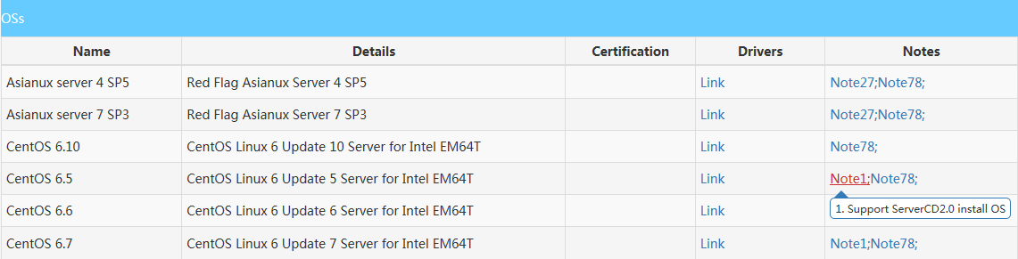

Failed to Upload an Upgrade Package
Symptom
The message "The description of the firmware type does not match the actual firmware type" is displayed.
Cause
The downloaded driver package is not applicable.
Solution
- Log in to Huawei Enterprise support website.
- In the PRODUCT SUPPORT area, choose Enterprise Data Center > Servers > Server Management Software > FusionServer iDriver.
- Click the FusionServer iDriver tab.
- Click the desired driver version.
- Download the correct driver package. Ensure that the driver package contains the driver.xml file.

How to Add a Server ESXi System to a vCenter Cluster
            - On the vCenter WebUI, choose Home > Inventories > Hosts and Clusters.
The Hosts and Clusters page is displayed.
            - Choose Datacenter from the shortcut menu.
            - Choose New Cluster.
The New Cluster page is displayed, as shown in Figure 1-1.
              - New Cluster page
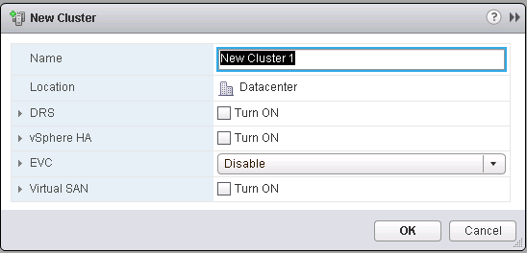

            - Enter a cluster name in Name, and click OK.
            - Right-click the newly created cluster.
            - Choose Add Host....
The Add Host page is displayed, as shown in Figure 1-1.
              - Add Host page
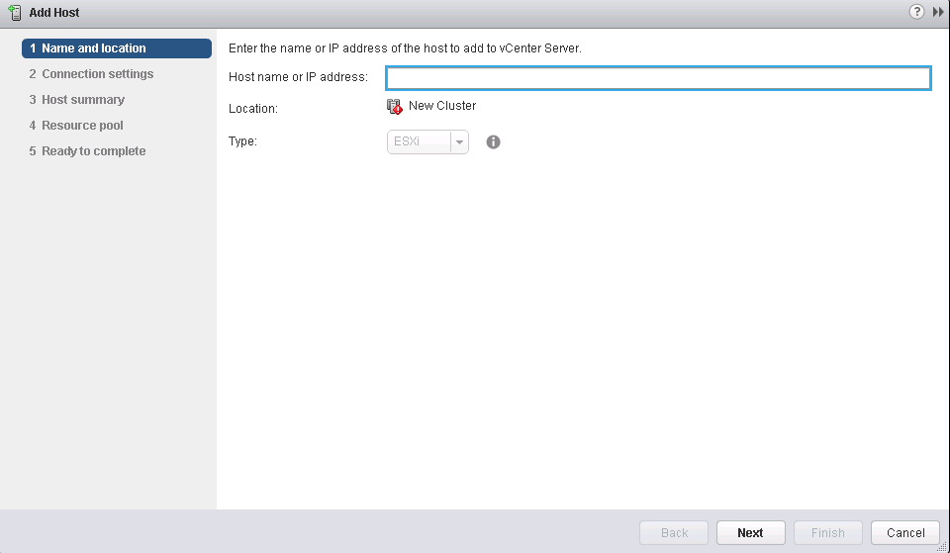

- On the Name and location page, enter the IP address of the server ESXi system.
- On the Connection settings page, enter the user name and password of the server ESXi system.
            - Click Finish. The ESXi system is added.
----End

